

Design and Implementation of Voice Controlled Application For Finance (Finansis)

Student ID: 18511510019

name: Mohamed Mohamud Mohamed Nur

Major: Computer science and Technology

College: College of Computer science and Artificial Intelligence

MOAHEMD MOAHMUD MOHAMED NUR 18511510019 of 2018 CS

College of Computer and Artificial Intelligence

A thesis submitted in partial satisfaction of the requirements

For The Degree of Bachelor in

Computer Science and Technology

Supervisor WU WINGO

May 2022

I Mohamed NUR with student id 18511510019 hereby declare that the Work presented in this thesis is original and carried out by myself, under the supervisor of WU WINGO, and with the help of people that provide free information on the internet (stack-overflow and YouTube) during the period 11 /2021 - 5/2022. The work presented in this thesis has not been submitted for any other degree.

ABSTRACT

A Voice assistant is a software agent that can perform tasks or services for an individual based on commands or questions. This project is a voice assistant named Finansis. The main problem that Finansis application tries to solve is to help people to create a passive income for them using the stock market. This application is inspired by Siri, (Siri is a virtual assistant that is part of Apple Inc.'s iOS). Finansis is developed for traders or normal people that interested in the stock market. The system is a web application that can be accessed through the internet. This system can be used for knowing the stock market news (real-time news), knowing current a stock price (real-time price), knowing stock information, showing a stock chart, interactive stock market searching, interactive user management, back-testing a trading strategy, and the most interesting is using Algorithmic Trading to trade stocks. This project is built on the MERN stack technologies (MongoDB, Express, React, Node).

**Keywords:** Voice assistant; Stock Market; Algorithmic Trading; Automation.

TABLE OF CONTENTS

LIST OF FIGURES vii

1 INTRODUCTION 1

1.1 System Development Environment Description 3

2 Literature review 5

2.1 Speech recognition 5

2.2 NLP 5

2.3 Speech synthesis 6

2.4 Algorithmic Trading 6

3 Technologies Used To Create Voice Assistant 7

3.1 Background info and pre-requisites 7

3.1.1 Introduction of NodeJS 7

3.1.2 Installation of NodeJS and NPM 7

3.1.3 Introduction of ReactJS 7

3.1.4 Creating ReactJS project using create-react-app 8

3.1.5 Introduction of react-speech-recognition 11

3.1.6 Installation of react-speech-recognition 11

3.1.7 Introduction of react-speech-kit 14

3.1.8 Installation of react-speech-kit 14

3.1.9 Your first voice assistant 16

4 REQUIREMENTS ANALYSIS 19

4.1 Functional requirement 19

4.2 Non-Functional Requirements 22

4.3 Commands 23

4.3.1 User management commands 23

4.3.2 Stock Market News commands 23

4.3.3 Stock information commands 24

4.3.4 voice-controlled app commands 24

4.3.5 interactive stock market searching commands 24

4.3.6 back-testing stock trading strategy commands 24

4.3.7 other commands 25

4.3.8 automating stock trading commands 25

5 SYSTEM DESIGN 26

5.1 Package diagram 27

5.2 Use case diagram 28

5.3 Data flow graph 29

5.3.1 The first data flow graph 29

Finansis first data flow graph contains 6 process: Finansis (React App), trading API, scraping news scrips, news API, main API and Auto API. The system contains two data-store: Trading database and main Database. The system contains one external entity: user (see Figure 9 DFD-1). 29

5.3.2 The second data flow graph 30

5.3.3 The third data flow graph 31

5.4 System flow chart 37

5.4.1 Getting news flow chart 37

5.4.2 Asking question flow chart 38

5.4.3 Opening chart flow chart 39

5.4.4 Starting back-testing flow chart 40

5.4.5 Zooming in or out flow chart 41

5.4.6 Buy stocks flow chart 42

5.4.7 Sell stocks flow chart 43

5.5 DATABASE DESIGN 44

5.5.1 Database Graphs 44

5.5.2 Database description 45

6 Implementation 48

6.1 User interface implementation 48

6.2 Commands implementation 52

7 Testing 71

8 Conclusion 94

8.1 Future Goals For The System overview 94

8.2 Drawback of Existing system 94

9 REFERENCE 95

LIST OF FIGURES

Figure 1 react app created successfully 9

Figure 2 after deleting files 9

Figure 3 react app running successfully 10

Figure 4 result of installing react-speech-recognition 13

Figure 5 useSpeechSynthesis file 14

Figure 6 final Result for simple-voice-assistant 18

Figure 7 Package diagrams 27

Figure 8 use case 28

Figure 9 DFD-1 29

Figure 10 DFD-2FD-2 30

Figure 11 DFD (Back-Testing)-3-1 31

Figure 12 DFD (Questions)-3-2 32

Figure 13 DFD (Stock Info)-3-3 33

Figure 14 DFD (User Management)-3-4 34

Figure 15 DFD (Stock Market News)-3-5 35

Figure 16 DFD (automating trading)-3-6 36

Figure 17 getting news flow chart 37

Figure 18 asking question flow chart 38

Figure 19 opening chart flow chart 39

Figure 20 start back-testing flow chart 40

Figure 21 zooming in or out flow chart 41

Figure 22 buy stock flow chart 42

Figure 23 sell stocks flow chart 43

Figure 24 database design 44

Figure 25 Home page 48

Figure 26 News page 48

Figure 27 Input model 49

Figure 28 Back-testing page 49

Figure 29 chart popup window 50

Figure 30 News detail popup window 50

Figure 31 Finansis Button 51

Figure 32 T1 test data 71

Figure 33 T1 showing news 72

Figure 34 T1 Finansis response 72

Figure 35 T1 Response from the API 72

Figure 36 T2 Test data 73

Figure 37 T2 Finansis response 73

Figure 38 T2 response from the API 73

Figure 39 T3 Test data 74

Figure 40 T3 showing News 74

Figure 41 T3 Finansis response 74

Figure 42 T3 response from the API 75

Figure 43 T4 showing the answer 76

Figure 44 T4 Finansis Response 76

Figure 45 T4 closed popup window 76

Figure 46 T5 Finansis Response 77

Figure 47 T6 MongoDB result before searching 78

Figure 48 T6 Finansis Response 79

Figure 49 T6 sending request to Auto API 79

Figure 50 T6 searching in DuckDuckGo 79

Figure 51 T6 response from auto API 79

Figure 52 T6 MongoDB result after searching 80

Figure 53 T6 showing the answer 80

Figure 54 T6 Finansis response 80

Figure 55 T7 Finansis opening popup to let a user choose a stock 81

Figure 56 T7 Finansis asking 81

Figure 57 T7 Finansis response 81

Figure 58 T7 opening the chart 82

Figure 59 T8 Finansis response 82

Figure 60 T8 opening Apple chart 83

Figure 61 T8 Finansis Response 83

Figure 62 T8 opening Tesla Chart 83

Figure 63 T9 Finansis opening popup to let a user choose a stock 84

Figure 64 T9 Finansis asking 84

Figure 65 T9 Finansis response 85

Figure 66 T9 sending a request to Auto API 85

Figure 67 T9 opening the chart using puppeteer 85

Figure 68 T10 test data 86

Figure 69 T10 Finansis Response 87

Figure 70 T10 requests sent to trading API 87

Figure 71 T10 Trading API logs 87

Figure 72 T10 Finansis response 88

Figure 73 T10 final result 88

Figure 74 T11 Finansis response 89

Figure 75 T11 sending request 89

Figure 76 T11 Finansis response 89

Figure 77 T11 trading API logs 90

Figure 78 T11 sending request to trading API 90

Figure 79 T11 Finansis response 90

Figure 80 T11 automate buy stocks 91

Figure 81 T12 Finansis Response 92

Figure 82 T12 send request 92

Figure 83 T12 trading API logs 92

Figure 84 T12 Finansis Response 92

Figure 85 T12 send request 92

Figure 86 T12 automating sell stocks 93

Figure 87 T12 Finansis Response 93

# INTRODUCTION

A voice assistant is a digital assistant that uses voice recognition, language processing algorithms and voice synthesis to listen to specific voice commands and return relevant information or perform specific functions as requested by the user. Based on specific commands, sometimes called intents, spoken by the user, voice assistants can return relevant information by listening for specific keywords and filtering out the ambient noise.

While voice assistants can be completely software based and able to integrate into most devices, some assistants are designed specifically for single device applications, such as the Amazon Alexa Wall Clock.

Today, voice assistants are integrated into many of daily devices such as cell phones, computers, and smart speakers. Because of their wide array of interactions. Some voice assistants offer a very specific feature set, while some choose to be open ended to help with almost any situation at hand.

Voice technology is now used worldwide. In the US alone, the number of people who use voice assistants and smart speakers—including those from Amazon, Google, and Apple—grow by double digits in 2020, fueled largely by stay-at-home behavior during the pandemic.

This Project is a voice assistant offers a very specific feature set. It contains 9 main modules: interactive user management, stock market news, stock information, speech recognition, voice-controlled app, speech synthesis, interactive stock market searching, back-testing stock trading strategy and automating stock trading using algorithmic trading.

This system can understand 59 different commands and other stock related questions (for example 'what is market capitalization').

This system can ask more than 14 yes/no questions, then respond something based on a user's answer. It can ask a user to choose a stock from a list of stocks.

This system has the ability to 'learn' about related Stock market questions and Stocks' symbol, actually, Finansis just search in DuckduckGo (a search engine like google) and then save the piece of information in the database.

Three mini-projects assist Finansis: news API, AUTO API, and Trading API, Trading API assists this system to buy and sell stocks using algorithmic trading, news API assists this system to save scraped news in the database and to let Finansis retrieve news from the database, news API is online[1] and AUTO API assists Finansis to control user’s browser using puppeteer.

There are four python scraping scripts running for 24 hours online, scraping news from yahoo finance, google finance, investing and seeking websites, and all that for free[2]

This system uses Yahoo Finance website to show users stocks information (for example opening yahoo finance chars).

## System Development Environment Description

In software, web and mobile application development, the development environment is a workspace with a set of processes and programming tools used to develop the source code for an application or software product. The environments are categorized into groups, including frontend, backend, browser, IDE, Scraping, Automation, operating system, and programming language.

* programming language
  + JavaScript ES6
  + Python 3.8.2
* operating system
  + Windows 10 Version 21H2 (Build 19044.1645)
* Browser
  + Google Chrome 101.0.4951.54 (Official Build) (64-bit) (cohort: Stable)
* IDE
  + Visual Studio Code@1.66.2
* Front-end
  + React@17.0.2
  + Styled-components@5.3.3
  + react-speech-recognition@3.9.0 (Web Speech API)
  + Axios@0.24.0
  + Redux@4.1.2
  + material-ui@4.10.1
* Back-end
  + Axios@0.24.0
  + bcrypt @5.0.1
  + Cors@2.8.5
  + Crypto@1.0.1
  + Dotenv @10.0.0
  + Express@4.17.1
  + Jsonwebtoken@0.2.0
  + Mongoose@6.1.1
  + MongoDB
* Scraping
  + Replit
  + Webbot@0.34
  + BeautifulSoup@4.10.0
* Automation
  + Puppeteer@13.0.0

# Literature review

## Speech recognition

Speech recognition, or speech-to-text, is the ability of a machine or [program](https://www.techtarget.com/searchsoftwarequality/definition/program) to identify words spoken aloud and convert them into readable text. Speech recognition works by breaking down the audio of a speech recording into individual sounds, analyzing each sound, using algorithms to find the most probable word fit in that language, and transcribing those sounds into text [3]. Speech recognition uses natural language processing (NLP) and deep learning neural networks.

## NLP

NLP algorithms are typically based on machine learning algorithms. Instead of hand-coding large sets of rules, NLP can rely on machine learning to automatically learn these rules by analyzing a set of examples (i.e. a large corpus, like a book, down to a collection of sentences), and making a statistical conclusion. In general, the more data analyzed, the more accurate the model will be[4].

## Speech synthesis

Speech synthesis is the computer-generated simulation of human speech. It is used to translate written information into aural information.

How does Speech Synthesis Work? There are 3 stages in which speech synthesis works; text to words, words to phonemes, and phonemes to sound:

* Text to words

The initial stage of speech synthesis, is generally called pre-processing or normalization, it is everything about reducing ambiguity: it’s about narrowing down the many different ways a person could read a piece of text into the one that’s the most appropriate.

* Words to phonemes

Phonemes are one of the smallest units of speech that make one word different from another word. Once they figure out the words that need to be spoken, next the speech synthesizer has to generate the speech sounds that make up these words. Every computer needs is a huge alphabetical list of words and details of how to pronounce each word. For each word, they would need a list of the phonemes that make up its sound.

* Phonemes to sound

At this point, the computer has converted the text into a list of phonemes. But how to find basic phonemes that the computer reads aloud when it’s turning the text into speech. There are three different approaches to this.

* First to use recordings of humans saying the phonemes
* The second is for the computer to generate the phonemes itself by generating basic sound frequencies
* The last approach is to imitate the technique of the human voice

## Algorithmic Trading

Algorithmic trading is a method of executing orders using automated pre-programmed trading instructions accounting for variables such as time, price, and volume. This type of trading attempts to leverage the speed and computational resources of computers relative to human traders [5].

# Technologies Used To Create Voice Assistant

## Background info and pre-requisites

The following few points are designed to get you started with developing rapidly and easily a voice assistant.

### Introduction of NodeJS

NodeJS is an open-source, cross-platform runtime environment for developing server-side web applications. NodeJS also has an event-driven architecture capable of asynchronous I/O.

### Installation of NodeJS and NPM

Installation of NodeJS and NPM is straightforward using the installer package available at NodeJS official web site.

* Download the installer from NodeJS WebSite (https://nodejs.org/en/).
* Run the installer.
* Follow the installer steps, agree the license agreement and click the next button

Now, let’s test NodeJS by printing its version using the following command in Command Prompt:

node -v

and test npm by printing its version using command

npm -v

### Introduction of ReactJS

React is a free and open-source front-end JavaScript library for building user interfaces based on UI components, We will use react to build our voice assistant because React makes it painless to create interactive UIs, and interactivity is important when it comes to voice assistant.

### Creating ReactJS project using create-react-app

In this step, you’ll create a new application using the npm package manager to run a remote script. The script will copy the necessary files into a new directory and install all dependencies.

When you installed Node, you also installed a package managing application called npm. Npm will install JavaScript packages in your project and also keep track of details about the project.

npm also includes a tool called npx, which will run executable packages. What that means is you will run the Create React App code without first downloading the project.

The executable package will run the installation of create-react-app into the directory that you specify. It will start by making a new project in a directory, which in this tutorial will be called simple-voice-assistant. Again, this directory does not need to exist beforehand; the executable package will create it for you. The script will also run ‘npm install’ inside the project directory, which will download any additional dependencies

To install the base project, run the following command:

npx create-react-app simple-voice-assistant

If you see the following message then you created react app successfully:

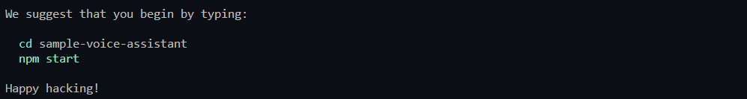

Figure 1 react app created successfully

Now open the project with your favorite IDE, I will use VSCode, Remove all unnecessary files, only leave App.js and index.js, your folder should look like the following image:

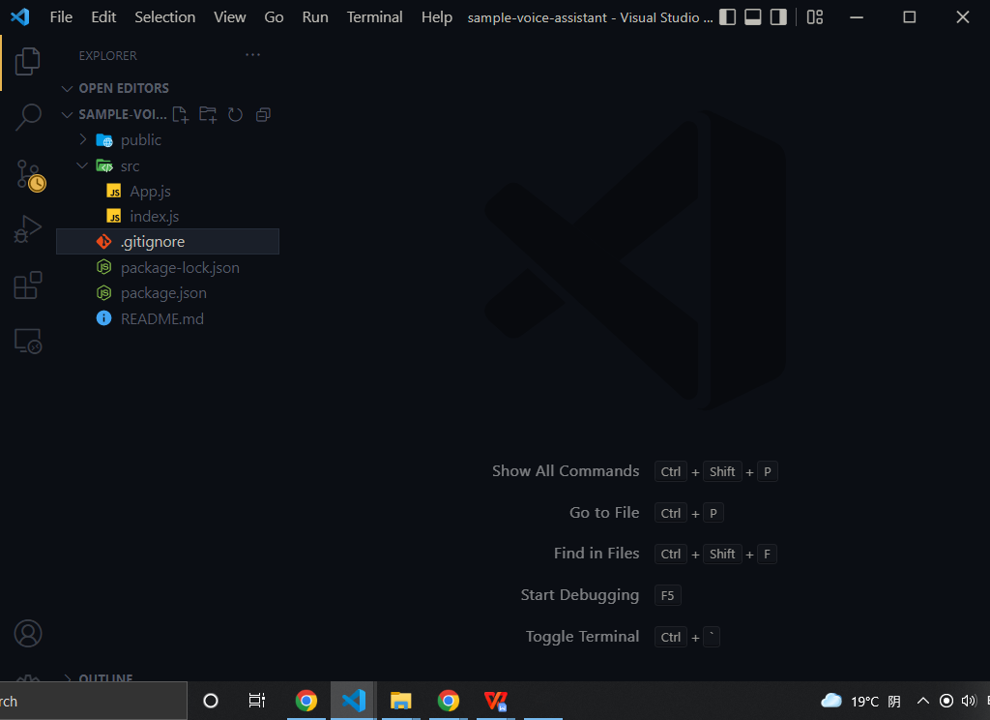

Figure 2 after deleting files

update App.js file like the following code:

function App() {

  return <div>simple voice assistant</div>;

}

export default App;

Update index.js file like the following code:

import React from "react";

import ReactDOM from "react-dom/client";

import App from "./App";

const root = ReactDOM.createRoot(

  document.getElementById("root")

);

root.render(

  <React.StrictMode>

    <App />

  </React.StrictMode>

);

Now run the following command to start react app in your localhost:8000:

npm start

If you see the following message in your command line you ran react project successfully:

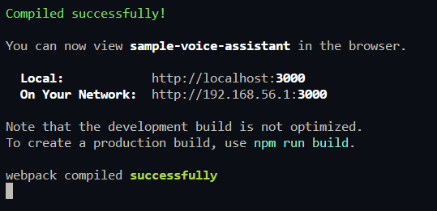

Figure 3 react app running successfully

### Introduction of react-speech-recognition

A React hook that converts speech from the microphone to text and makes it available to your React components.

Under the hood, it uses Web Speech API. Note that browser support for this API is currently limited, with Chrome having the best experience.

### Installation of react-speech-recognition

run the following command to install react-speech-recognition:

npm install react-speech-recognition

Let check out if we installed react-speech-recognition successfully

updating App.js:

First import speechReconition and useSpeechReconition from react-speech-recongition. useSpeechRecognition is React hook for consuming speech recorded by the microphone. SpeechRecognition is Object providing functions to manage the global state of the microphone :

import SpeechRecognition, {

  useSpeechRecognition,

} from "react-speech-recognition";

Call useSpeechReconition in App react functional component and retrieve transcript, listening, resetTranscript and browserSupportsSpeechRecognition from it. Transcript is a string variable containing a transcription of all speech that has been spoken into the microphone. Listening is a boolean variable If true, the Web Speech API is listening to speech from the microphone. resetTranscript is function to sets transcript to an empty string. browserSupportsSpeechRecognition is a boolean variable if true, a user’s browser supports web speech API:

function App() {

  const {

    transcript,

    listening,

    resetTranscript,

    browserSupportsSpeechRecognition,

  } = useSpeechRecognition();

checking browser support for Web Speech API, if not show a user ‘browser doesn’t support speech recognition’ and stop executing App.js file:

  if (!browserSupportsSpeechRecognition) {

    return (

      <span>Browser doesn't support speech recognition.</span>

    );

  }

Creating commonStyle object to pass common style to divs

  const commonStyle = {

    display: "flex",

    justifyContent: "center",

    alignItems: "center",

    gap: "10px",

  };

displaying html to the browser and adding onClick event listener to each button:

  return (

    <div

      style={{

        ...commonStyle,

        flexDirection: "column",

        height: "100vh",

      }}

    >

      <p>Microphone: {listening ? "on" : "off"}</p>

      <div

        style={{

          ...commonStyle,

        }}

      >

        <button onClick={SpeechRecognition.startListening}>

          Start

        </button>

        <button onClick={SpeechRecognition.stopListening}>

          Stop

        </button>

        <button onClick={resetTranscript}>Reset</button>

      </div>

      <p>{transcript}</p>

    </div>

  );

}

export default App;

Now if you click on Start button and then say ‘can you here me’ you should see something like the following image:

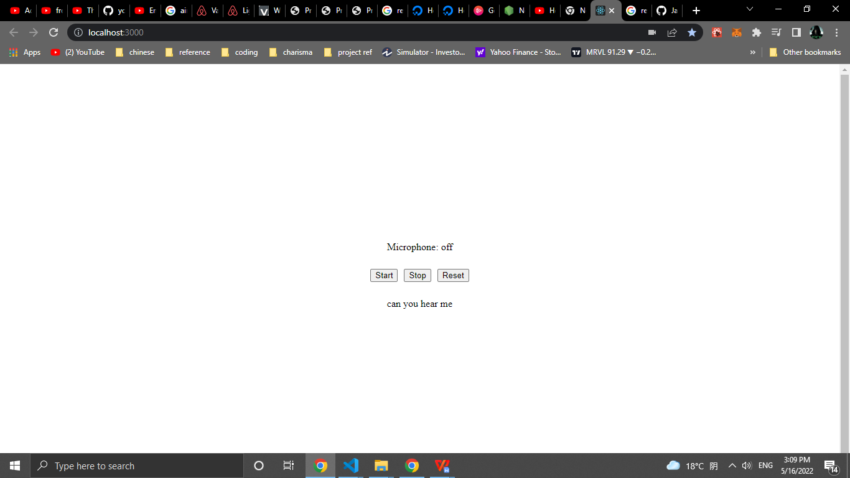

Figure 4 result of installing react-speech-recognition

### Introduction of react-speech-kit

React hooks for in-browser Speech Recognition and Speech Synthesis. We only going to useSpeechSynthesis function from this package.

### Installation of react-speech-kit

Now run the following command to install react-speech-kit:

npm install react-speech-kit

If you had an error like me while installing react-speech-kit so go to <https://github.com/MikeyParton/react-speech-kit/blob/master/src/useSpeechSynthesis.jsx> and then create file named useSpeechSynthesis in the src directory and lastly copy the code to it.

useSpeechSynthesis file should look like the following image:

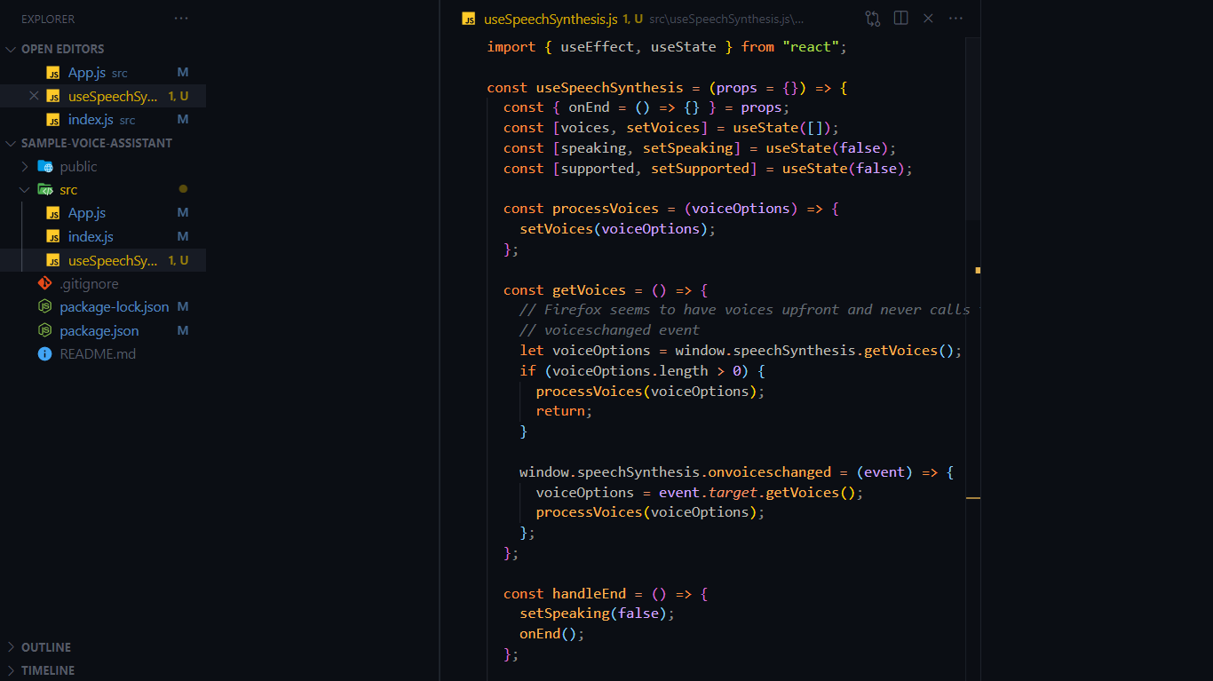

Figure 5 useSpeechSynthesis file

import useSpeechSynthesis in App.js file:

import SpeechRecognition, {

  useSpeechRecognition,

} from "react-speech-recognition";

*// new code*

import useSpeechSynthesis from "./useSpeechSynthesis";

*// end of the new code*

function App() {

...

Let test useSpeachSynthesis now, we need to update App.js again, import useEffect hook from react, The useEffect Hook allows you to perform side effects in your components, in our case the side effects are user’s commands :

*//start of new code*

import { useEffect } from "react";

*// end of the new code*

Retrieve finalTranscript from useSpeechRecongnition. finalTranscript is a string variable containing a transcription of speech that the Web Speech API has finished processing:

function App() {

  const {

    transcript,

    listening,

*//start of new code*

    finalTranscript,

*// end of the new code*

    resetTranscript,

    browserSupportsSpeechRecognition,

  } = useSpeechRecognition();

Call useSpeechSynthesis in App react functional component and retrieve speak and voices from it. Speak is function used to make the browser read some text. Voices is An array of available voices which can be passed to the speak function. Source code:

*//start of new code*

  const { speak, voices } = useSpeechSynthesis();

*// end of the new code*

Call useEffect hook and pass a callback function that will be execute when finalTranscript changes. finalTranscript will change when a user commands. In side the callback, we first check if finalTranscript is empty, if false so then check if finalTranscript equals ‘can you hear me’, if true call speak function and pass text equals ‘yes, I can …’ and voice equals ‘voices[7]’, if false call speak function pass different text this time which is ‘i don't understand’. source code:

*//start of new code*

  useEffect(() => {

    if (finalTranscript) {

      if (finalTranscript === "can you hear me") {

        speak({

          text: "yes, I can , and congratulations for your first voice assistant app",

          voice: voices[7],

        });

        console.log({ finalTranscript });

      } else {

        console.log("i don't understand");

        speak({

          text: "i don't understand",

          voice: voices[7],

        });

      }

    }

*// eslint-disable-next-line react-hooks/exhaustive-deps*

  }, [finalTranscript]);

*// end of the new code*

. . .

Now if you click on Start button and then say ‘can you here me’ you should hear ‘yes, I can , and congratulations for your first voice assistant app’

### Your first voice assistant

Let’s now add two more commands to change the background color by adding the following code in App.js:

Importing useState hook from react:

*//start of new code*

import { useEffect, useState } from "react";

*// end of the new code*

*. . .*

Creating bgColor state and creating changeBGColor function:

. . .

  const { speak, voices } = useSpeechSynthesis();

*//start of new code*

  const [bgColor, setBgColor] = useState("white");

  const changeBGColor = (color) => {

    speak({

      text: `changing background to ${color}`,

      voice: voices[7],

    });

  };

*// end of the new code*

creating ‘change the background to red’ command and ‘change the background to white’ command in useEffect hook:

useEffect(() => {

    if (finalTranscript) {

      if (finalTranscript === "can you hear me") {

        speak({

          text: "yes, I can , and congratulations for your first voice assistant app",

          voice: voices[7],

        });

        console.log({ finalTranscript });

      }

*//start of new code*

      else if (

        finalTranscript === "change the background to red"

      ) {

        changeBGColor("red");

        setBgColor("red");

      } else if (

        finalTranscript === "change the background to White" ||

        finalTranscript === "change the background to white"

      ) {

        changeBGColor("white");

        setBgColor("white");

      }

*// end of the new code*

      else {

        console.log("i don't understand");

        speak({

          text: "i don't understand",

          voice: voices[7],

        });

      }

}

. . .

Adding bgColor state to the first div’s style

. . .

  return (

    <div

      style={{

        ...commonStyle,

        flexDirection: "column",

        height: "100vh",

*//start of new code*

        background: bgColor,

*// end of the new code*

      }}

    >

      <p>Microphone: {listening ? "on" : "off"}</p>

. . .

Now if you click on Start button and then say ‘change the background to red’ you should hear ‘changing background to red’ and the background should change to red like the following image:

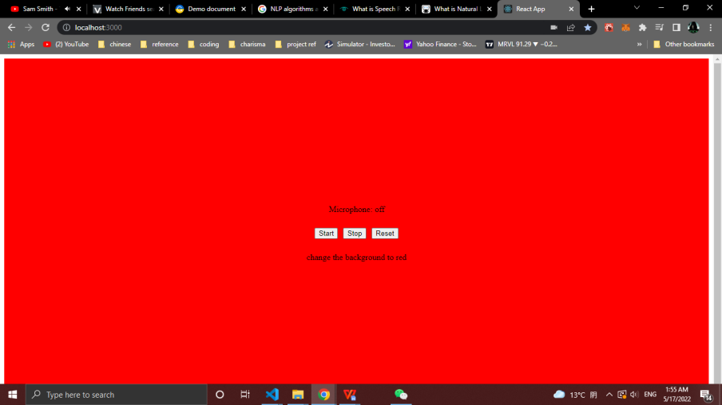

Figure 6 final Result for simple-voice-assistant

the full source code for this simple voice assistant in the following GitHub:

<https://github.com/nur1208/simple-voice-assistant>

Note: That is not my project, that is just an example of how you can create simple voice assistant.

# REQUIREMENTS ANALYSIS

## Functional requirement

The modules involved are:

* + - Interactive User Management
    - Stock Market News
    - Stock Information
    - Speech recognition
    - voice-controlled app
    - Speech synthesis
    - interactive stock market searching
    - Back-testing stock trading strategy
    - Automating stock trading  **(**Trading bot**)**

**Interactive User management** module contains all functionality related to users. a user can register to the app, can log in, can update his information, can update her password, can add and remove stocks from her watch list, and if a user forgets his password a user can create a new password by receiving a reset token in her email interactively.

**The Stock Market News** module contains all functionality related to the news. getting news by source, keyword in the headline, latest or top stories. Get more news. scraping news from yahoo finance, google finance, investing, and seeking websites. saving scraped news in the database. letting Finansis start reading news headlines from the first article, start reading them from specific article's number, or stop reading them. opening article's details page with help of Finansis or without, if a window opened with Finansis’s help, Finansis can scroll the window.

**Stock information** module contains all functionality related to stock information. opening stock chart using yahoo finance's charts with Finansis's help or without, if the chart is opened with Finansis's help, Finansis can change the chart's type daily, 1 minute, or whatever valid type, and Finansis can also zoom the chart in or out. opening multiple charts at once only without Finansis's help. Get the stock's current price (real-time price) for free using the following API (URL: [14]). Helping Finansis to learn about companies. showing users the most active, gainers, or losers stocks by opening yahoo finance stocks screeners. showing users a stock statistics by opening yahoo finance stock statistics section. showing users sold stocks by opening yahoo finance stock chart and then changing the date range to equal date of buying and selling of the sold stock.

**Speech recognition** module enable users to speak to Finansis and Finansis understand them, Speech Recognition module is the most important module in this project, I used react-speech-recognition package which uses Web speech API. Speech Recognition model is create by w3c community group[16][17].

**voice-controlled app** module is to control the app by telling Finansis commands using Speech recognition module. navigating between pages by telling Finansis 'go forward', 'go back' or 'go to {news|info|...} page' ({news|info|..} is dynamic values, for example: 'go to news page'). zooming in or out charts, scrolling news page, scrolling details news page. closing any popup window.

**Speech synthesis** module is to make Finansis speak out loud. responding to users, asking users yes/no questions, or asking users to choose a stock from a stock list. stopping Finansis from recognizing when Finansis start speaking out loud.

**Back-testing stock trading strategy** module is to let users test stock trading strategy of this application. users will input start date, end date, initial cash, and account risk per trade. This module also helps developers of this app to come up with a better trading strategy.

**Interactive stock market searching** module is to let users ask questions about the stock market and then Finansis answers the question, if the answer of the question not exist in the database, then Finansis will search in the DuckduckGo (a search engine like Google) and after that save the answer in the database and lastly answer the question so if someone asked the same question again Finansis just answer it.

**Automating stock trading (Trading Bot)** module is to let Finansis buy, sell and set stop loss for stocks using Algorithmic Trading. the trading flow first set stop loss for bought stocks, second find sell signals for bought stocks and then sell them if a signal has been found, third scrap S&P 500 stocks, and then save them in python array, fourth loop through all S&P 500 stocks to find buy signals then save them in the database if a signal has been found, lastly, get found buy signal stocks from the database and then buy them. in this project for current version 1.0 all buy and sell stocks in a simulator for the stock market I used Investopedia's simulator (URL: [18]).

## Non-Functional Requirements

Nonfunctional requirements is the quality attributes, design, and implementation constraints, and external interfaces which a product must have.

Following are functional requirements of the project.

* Exception handling must be used.
* User should get confirmation and warning message.
* Users are well secured
* The user interface must be friendly.
* User should get maximum performance of the app.

## Commands

In this section you can find all possible commands that Finansis understand.

Some notes you should know about Finansis commands:

- if a word between brackets () that means the word is optional.

- if a word between curly brackets{} that means the word is dynamic.

- Vertical bar | symbol is separator between the dynamic options for a command.

- three periods ... means that there are more dynamic options then words inside curly brackets {}.

### User management commands

This system provide 10 different command for User management module:

* sign up
* login
* forgot (my) password
* update my information
* logout
* update (my) password
* add {Apple|AAPL|...} stock to (my) watch list
* delete {Apple|AAPL|...} stock from (my) watch list
* open (my) watch list

### Stock Market News commands

This system provide 10 different command for Stock Market News module:

* Give me the news from {yahoo finance|investing|seekingalpha}
* open article (number) {1|5|...}
* what's up with {Apple|China|...}
* Give me the latest news
* read the news
* give me more news
* start reading (news) from article {1|5|...}
* open article (number) {1|5|...} without control
* give me top stories
* give me {Apple|AAPL|...} stock news

### Stock information commands

This system provide 9 different command for Stock information module:

* open {Apple|AAPL|...} (symbol) chart
* give me {Apple|AAPL|...} statistics
* give me The most {actives|gainers|losers} stocks
* give me trending stocks
* open {Apple|AAPL|...} (symbol) chart with your control
* what is the current price for {Apple|AAPL|...} (symbol)
* show me {Apple and Tesla|AAPL and DD|Apple and Tesla and amazon|...} charts

### voice-controlled app commands

This system provide 5 different command for voice-controlled app module:

* go back
* go to {info|news|...} (page)
* close the window
* zoom {in|out}
* change the chart to {1 minute|1 hour|...}

### interactive stock market searching commands

This system provide more than 4 different command for interactive stock market searching module:

* open details page for the answer
* what is market capitalization
* other questions exist in the database
* and any unknown command start with 'how' or 'what'

### back-testing stock trading strategy commands

This system provide 4 different command for back-testing stock trading strategy module:

* start back testing
* reset back testing (data)
* force sell
* sell with profit or without

### other commands

The following commands are 10 different general command:

* stock (number) {1|5|...}
* what can you do
* what is your name
* (of course) yes
* no
* do you have a boyfriend
* can you hear me
* stop listening
* thank you
* what's the date today

### automating stock trading commands

This system provide 8 different command for back-testing stock trading strategy module:

* buy stocks
* sell stocks
* set stop-loss for stocks
* trade stocks for me
* find buy signals
* show me (a) chart for found buy signals (stocks)
* sold stocks chart
* show me trading progress

## 

# SYSTEM DESIGN

Software design sits at the technical kernel of the software engineering process and is applied regardless of the development paradigm and area of application. Design is the first step in the development phase for any engineered product or system. The designer’s goal is to produce a model or representation of an entity that will later be built. Beginning, once system requirement has been specified and analyzed, system design is the first of the three technical activities - design, code and test that is required to build and verify software.

During design, progressive refinement of data structure, program structure, and procedural details are developed reviewed and documented. System design can be viewed from either technical or project management perspective. From the technical point of view, design is comprised of four activities – architectural design, data structure design, interface design and procedural design.

## Package diagram

Package diagrams are structural diagrams used to show the organization and arrangement of various model elements in the form of packages.

This system contains 6 main packages: Finansis UI, main API, trading API, news API, news scraping scripts and Auto application. Finansis UI package contains 6 sub-packages: market news, stock information, interactive searching, interactive user management, back-testing trading strategy and automating stock trading. Trading API contains 2 sub-packages: trading stocks data and algorithmic trading. Main API contains 3 sup-packages: user data, company data and question data. Auto application contains 4 sup-packages: controlling popup management, company scraping scripts, question scraping scripts and sending emails management. The following Diagram is Finansis’s Package diagram (Figure 7 Package diagram):

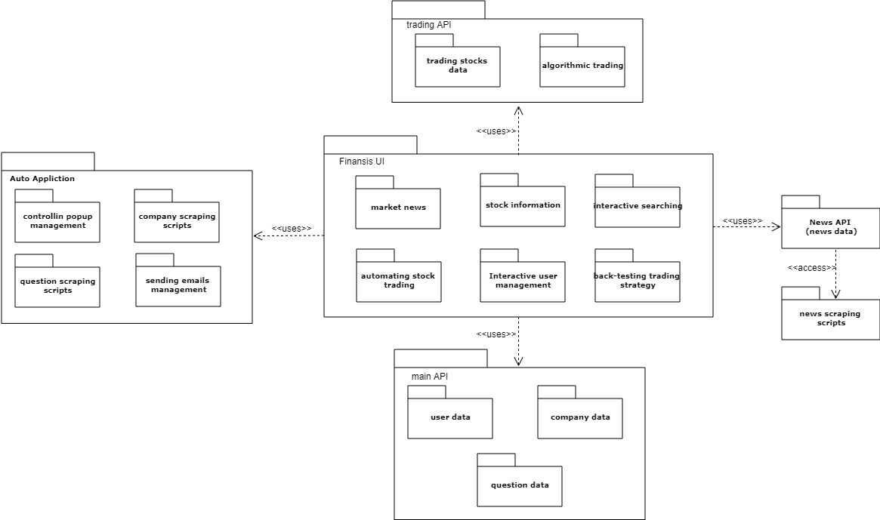

Figure 7 Package diagrams

## Use case diagram

a use case diagram can summarize the details of your system's users (also known as actors) and their interactions with the system. This system contains 17 cases and 1 actors. The user can interact with 11 case (see figure 8 use case) .

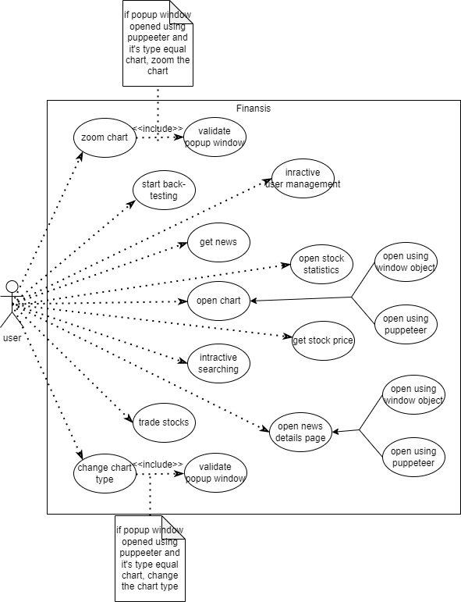

Figure 8 use case

## Data flow graph

A data-flow graph is a graph which represents a data dependencies between a number of operations. In this section you will find the first, second and third data-flow graphs for Finansis.

### The first data flow graph

Finansis first data flow graph contains 6 process: Finansis (React App), trading API, scraping news scrips, news API, main API and Auto API. The system contains two data-store: Trading database and main Database. The system contains one external entity: user (see Figure 9 DFD-1).

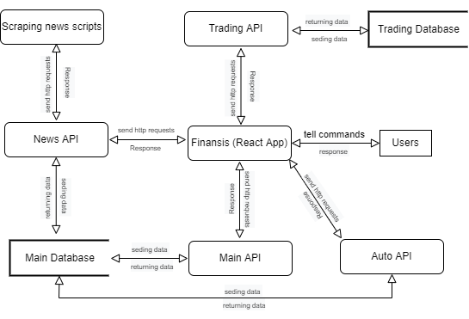

Figure 9 DFD-1

### The second data flow graph

This system second data flow graph contains 11 process: back-testing, automating trading, questions module, stock information, user management, voice control, stock market news, trading API, main API, news API and Auto API, it contains two data-store: Trading database and main Database and it contains one external entity: user (see Figure 10 DFD-2FD-2).

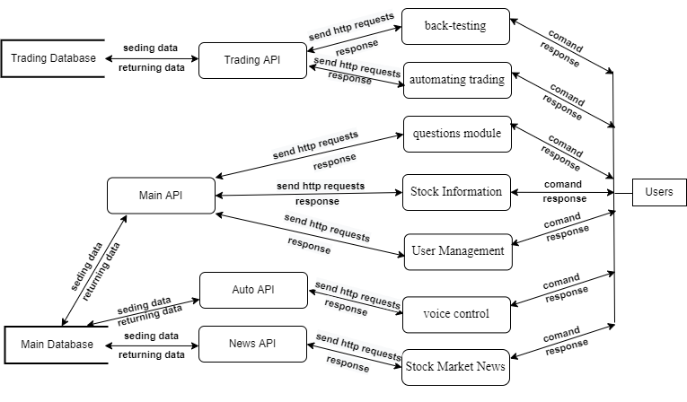

Figure 10 DFD-2FD-2

### The third data flow graph

Back-testing module contains 11 process, two data-stores and one external entity (see Figure 11)

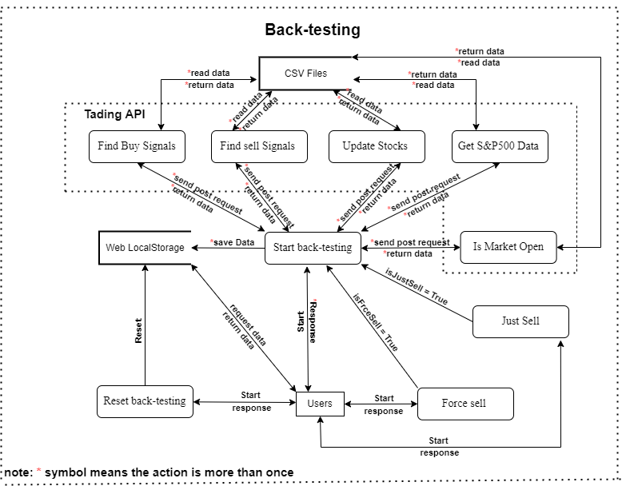

Figure 11 DFD (Back-Testing)-3-1

Questions module contains 4 process, one data-stores and one external entity (see Figure 12)

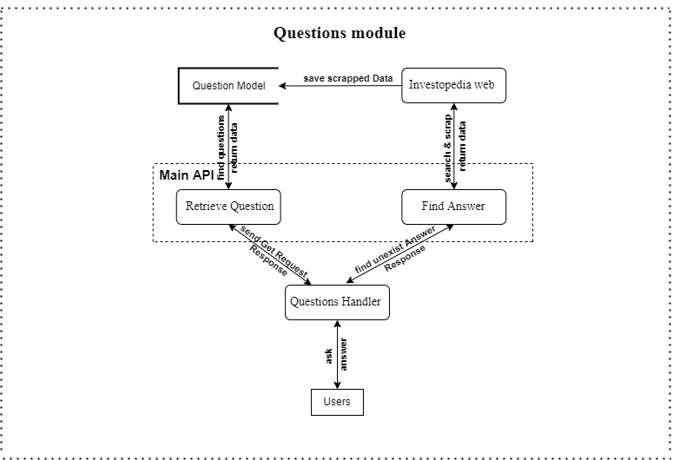

Figure 12 DFD (Questions)-3-2

Stock Information module contains 13 process, two data-stores and one external entity (see Figure 13)

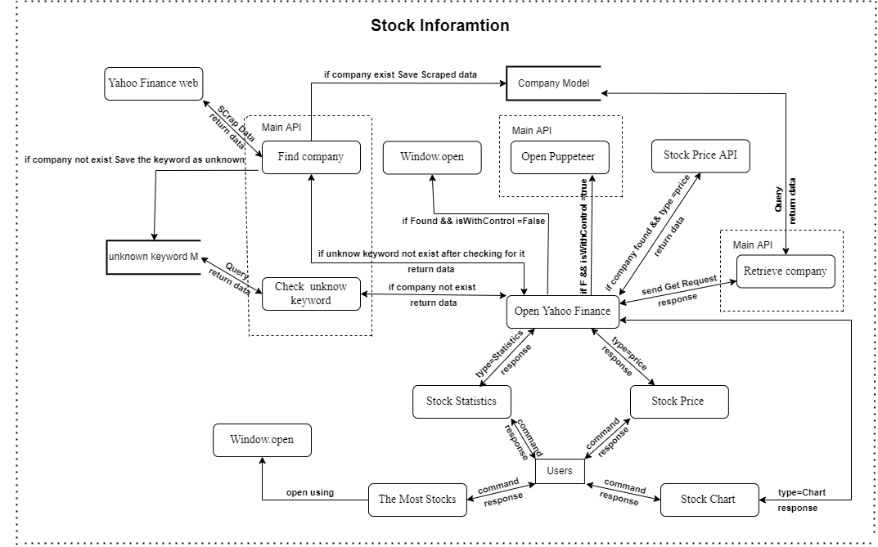

Figure 13 DFD (Stock Info)-3-3

User management module contains 15 process, one data-stores and one external entity (see Figure 14)

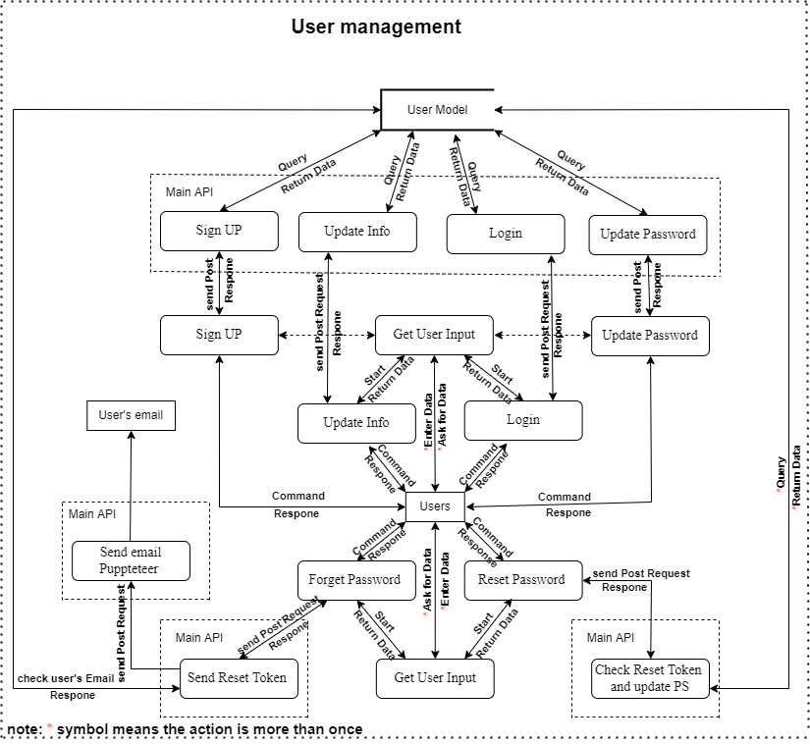

Figure 14 DFD (User Management)-3-4

Stock market new module contains 11 process, 5 data-stores and 2 external entity (see Figure 15)

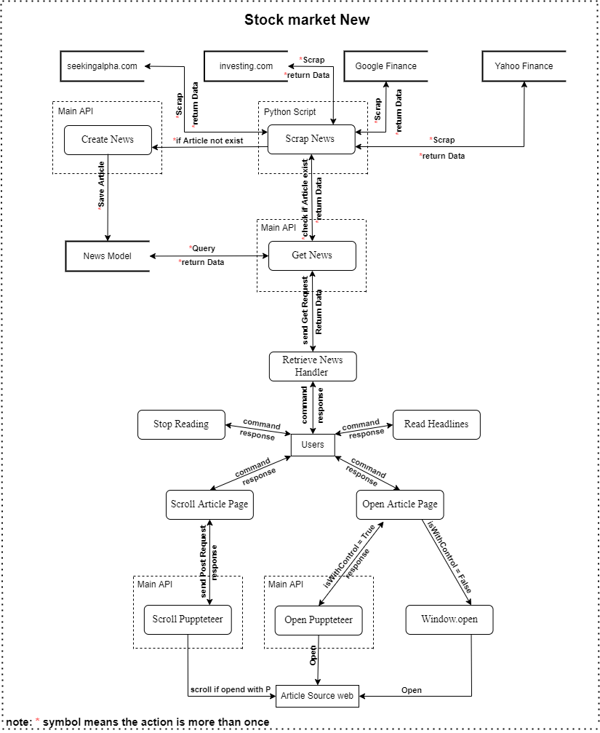

Figure 15 DFD (Stock Market News)-3-5

Automating trading module contains 13 process, two data-stores and 2 external entity (see Figure 16)

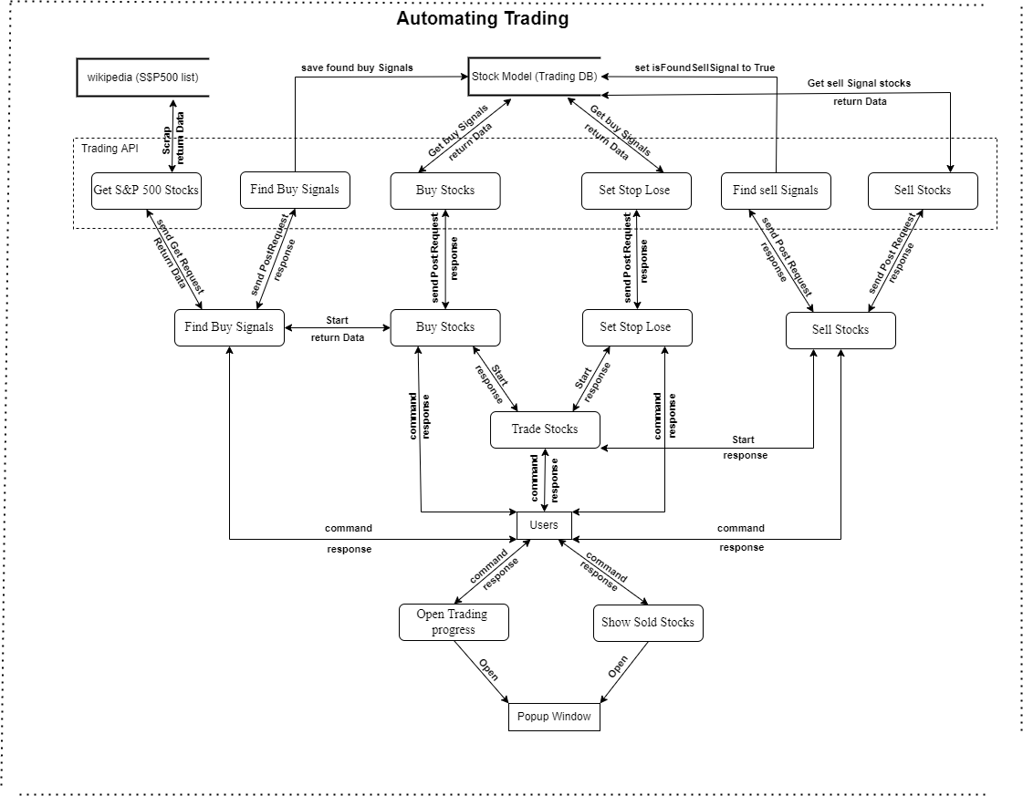

Figure 16 DFD (automating trading)-3-6

## System flow chart

A flowchart is a picture of the separate steps of a process in sequential order. It is a generic tool that can be adapted for a wide variety of purposes, and can be used to describe various processes. In this section you will find the main processes flow chart for Finansis.

### Getting news flow chart

as a user looking to read news headlines or letting Finansis read them for him, he can command ‘give me the news from {Yahoo Finansis}’ the next step would be for Finansis to make a call to News API to fetch news from the database, and then display the news to the user, if didn’t find news so then tell him ‘sorry, I didn't find news from {source} ‘ (See Figure 17 below)

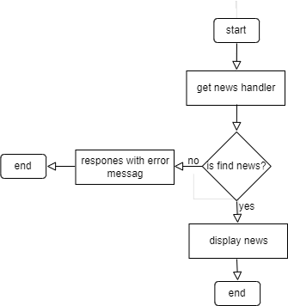

Figure 17 getting news flow chart

### Asking question flow chart

a user ask a question for example ‘what is market capitalization’, if an answer for the question is exist in the database so then answer the user, otherwise ask a user ‘do you want me to find answer for 'what is market capitalization', if a user answer is yes so then scrap an answer and then answer the user if a user answer is no so then end this process. (See Figure 18 below)

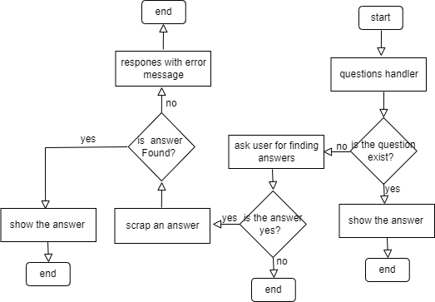

Figure 18 asking question flow chart

### Opening chart flow chart

a user command "open Apple chart’' if found a stock for apple in the database so then open Apple chart otherwise ask a user ‘do you want me to learn about {apple} company’ if a user answer is ‘yes’ so then search for the symbol and then scrap it if the symbol found open the chart if didn't find a symbol so then save the symbol as an unknown keyword in the database and then end this process, if a user answer is 'no' for the pervious question so then end this process. (See Figure 19 below)

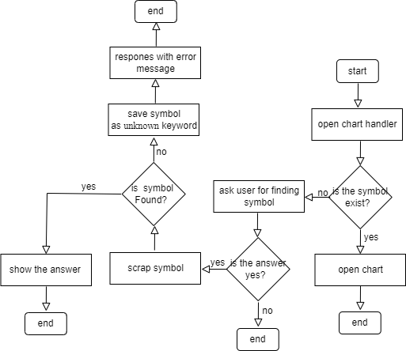

Figure 19 opening chart flow chart

### Starting back-testing flow chart

A user command ‘start back-testing, so then Finansis will call startBacktesting function, in the function first it will send a request to ‘is market open’ endpoint and if the request returns an error so then send the request again and only go to the next step if the request sent successfully and the same process for ‘get sp500 data’ endpoint, ‘update current price’ endpoint, ‘sell stocks’ endpoint and ‘buy stocks’ endpoint, only stop this process when start date equal end date. (See Figure 20 below)

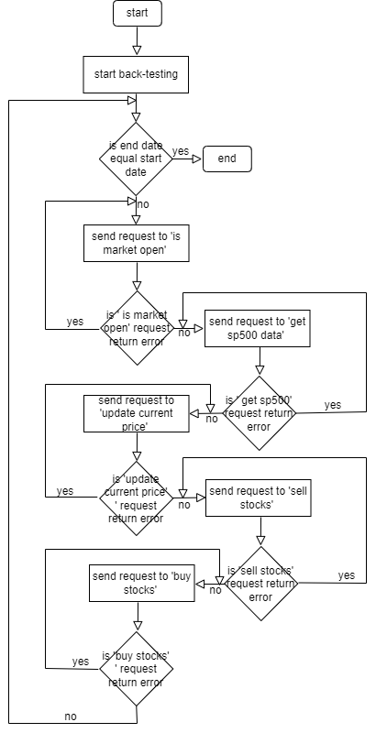

Figure 20 start back-testing flow chart

### Zooming in or out flow chart

A user command ‘zoom in’ or ‘zoom out’, first check if the zooming type is valid (valid options in or out) if the condition is false so stop this process, otherwise go to the next step which is to check if a chart window is open using puppeteer, if the condition is false so stop this process, otherwise zoom in or out the chart. (See Figure 21 below)

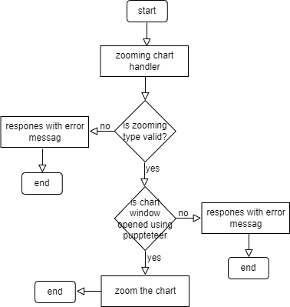

Figure 21 zooming in or out flow chart

### Buy stocks flow chart

A User commands ‘buy stocks’, so then Finansis will call buy stocks handler, which will call find buy signals handler, in find buy signals handler first it will send request to ‘save sp500 stocks’ endpoint, if the request returned an error so then stop this process otherwise send request to ‘find buy signals’ endpoint if the request returned an error so then stop this process otherwise return total number of found buy signals to buy stocks handler, if didn’t find any buy signal so then stop this process otherwise send request to ‘buy stocks’ endpoint to buy stocks using puppeteer automation functionality. (See Figure 22 below)

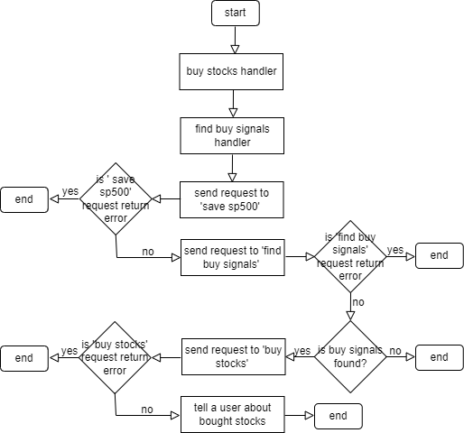

Figure 22 buy stock flow chart

### Sell stocks flow chart

A user command ‘sell stocks’, so then Finansis will call sell stocks handler, which will send a request to ‘find sell signals’ endpoint and if found sell signals so then send a request to ‘sell stock’ endpoint to sell stock using puppeteer automation functionality, if any of the previous requests return an error so then ask a user ‘do you want me to try to sell again ’ if the user says ‘yes’ call sell handler again, otherwise stop this process. (See Figure 23 below)

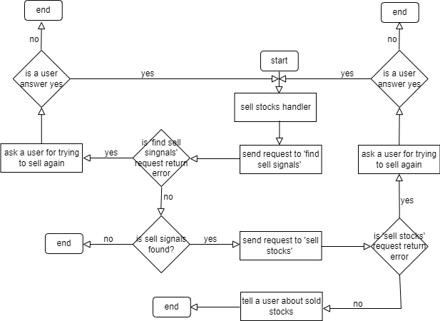

Figure 23 sell stocks flow chart

## DATABASE DESIGN

### Database Graphs

I design 5 tables for this system: user, unknownKeywordForCompany, question, news, company

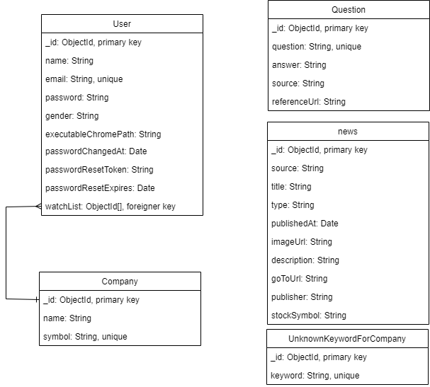

Figure 24 database design

### Database description

In this section you will find detail description for each database table in this system

* User

The user table contains users data, it has 11 fields:

|  |  |  |  |
| --- | --- | --- | --- |
| Field name | Field description | Type | Remarks |
| _id | This field contains the user's id, which serves as a primary key. | String | required: true,  Unique: true |
| name | This field contains user’s name | String | required: true, |
| password | the user's password | String | required: true,  select: false |
| gender | the user's gender | String | required: true,  enum:["male","female"] |
| email | the user's email address | String | required: true,  unique: true |
| executableChromePath | the user's executable chrome path, it used to let this system control user’s chrome | String |  |
| chromeDataPath | the user's chrome data path, it used to add user chrome data when opening chrome using this system | String |  |
| passwordChangedAt | This field stores last time a user changed his password, it used for security reasons | String |  |
| passwordResetToken | This field stores password reset token after sending reset token to a user, it used to valid user reset token | String |  |
| passwordResetExpires | This field stores expire date for password reset token | Date |  |
| watchList | User’s stocks watch list | [ObjectId] | ref: "Company" |

Table 1 user

* Company

The company table contains scraped company information from Yahoo finance website, it has 3 fields:

|  |  |  |  |
| --- | --- | --- | --- |
| Field name | Field description | Type | Remarks |
| _id | This field contains the company's id, which serves as a primary key. | String | required:true,  Unique: true |
| symbol | This field stores company stock’s symbol | String | unique: true,  index: true |
| name | This field stores company’s name | String |  |

Table 2 company

* Question

The question table contains all scraped data related to a question, the data scraped from investopedia.com, it has 5 fields:

|  |  |  |  |
| --- | --- | --- | --- |
| Field name | Field description | Type | Remarks |
| _id | This field contains the question's id, which serves as a primary key. | String | required:true,  Unique: true |
| question | This field stores the question | String | unique: true, |
| answer | This field stores the answer | String |  |
| source | This field stores the answer’s source, it used to let the user know from which website the answer | String |  |
| referenceUrl | This field stores the answer reference’s URL, it used to open the details page for the answer | String |  |

Table 3 question

* unknownKeywordForCompany

The unknownKeywordForCompany table contains known keyword for company that this system tried to scrap but it didn’t find result for the keyword from Yahoo finance website, it help the system to remember unknown keyword so no need to try to scrap data again, it has 2 fields:

|  |  |  |  |
| --- | --- | --- | --- |
| Field name | Field description | Type | Remarks |
| _id | This field contains the question's id, which serves as a primary key. | String | required:true,  Unique: true |
| question | This field stores the question | String | unique: true, |

Table 4 unkownKeywordForCompany

* News

The news table contains scraped news from yahoo fiances, investing.com and seekingalpha, it has 10 fields:

|  |  |  |  |
| --- | --- | --- | --- |
| Field name | Field description | Type | Remarks |
| _id | This field contains the news id, which serves as a primary key. | String | required: true,  Unique: true |
| source | This field stores the news source, it used to let the user know from which website the news | String |  |
| title | News title | String |  |
| type | News type, possible types: business, world, Lifestyle and more | String |  |
| publishedAt | This field stores the data news published at | Date |  |
| imageUrl | News image URL | String |  |
| description | News description | String |  |
| goToUrl | This field stores the news reference’s URL, it used to open the details news page | String |  |
| publisher | News publisher | String |  |
| stockSymbol | News belongs to which stock | String |  |

# Implementation

## User interface implementation

In this sections you will see user Interface implementation. This system contains 5 pages: Home, info, News and back-testing. The System has 4 modals: Info, progress , info with icon and input modals.

* Home page

In the home page a user can see different possible sections for this system and one example command for each section. The system contains 3 main sections: news, stocks information and trading. Each section has page similar to the home page.

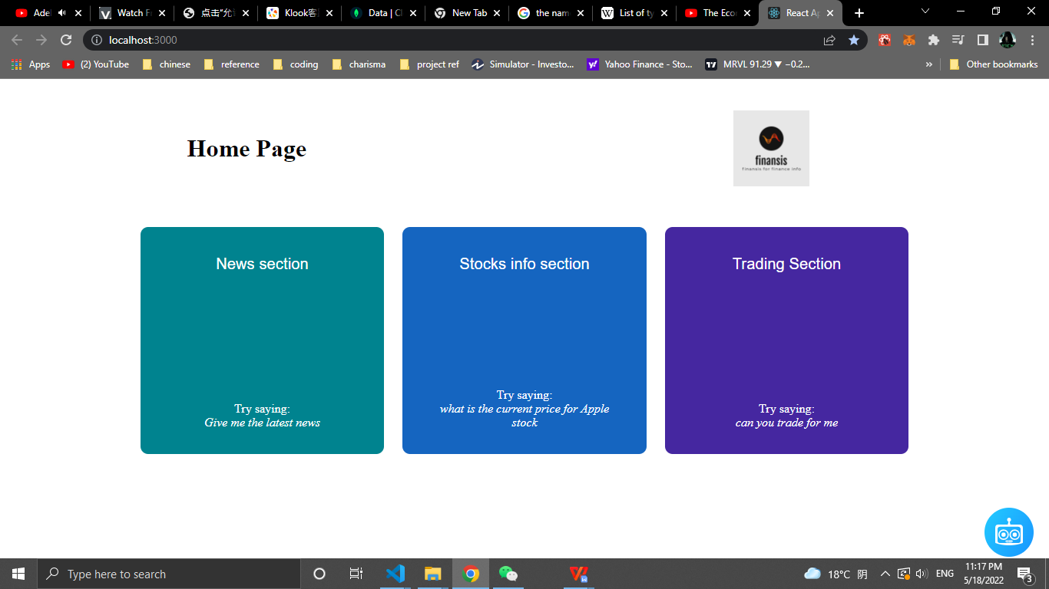

Figure 25 Home page

* News page

News page is for displaying news to a user as requested

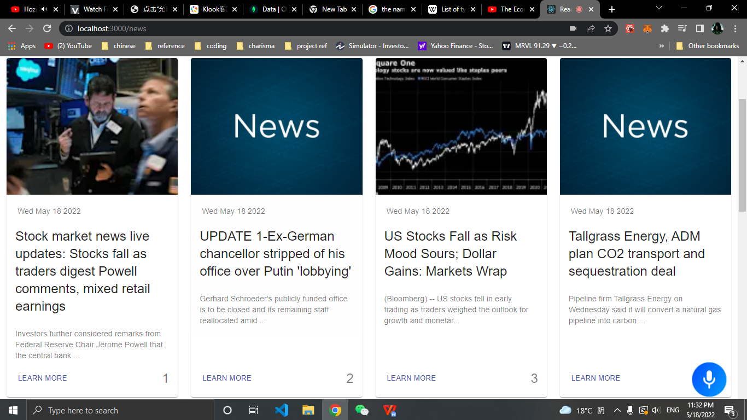

Figure 26 News page

* Input model

Input model helps users to enter their information interactively.

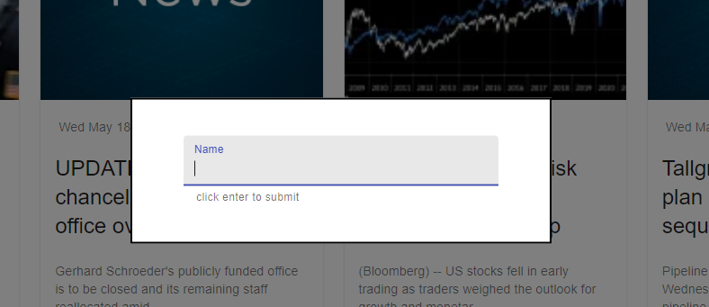

Figure 27 Input model

* Back-testing page

In back-testing page users can view back-testing results.

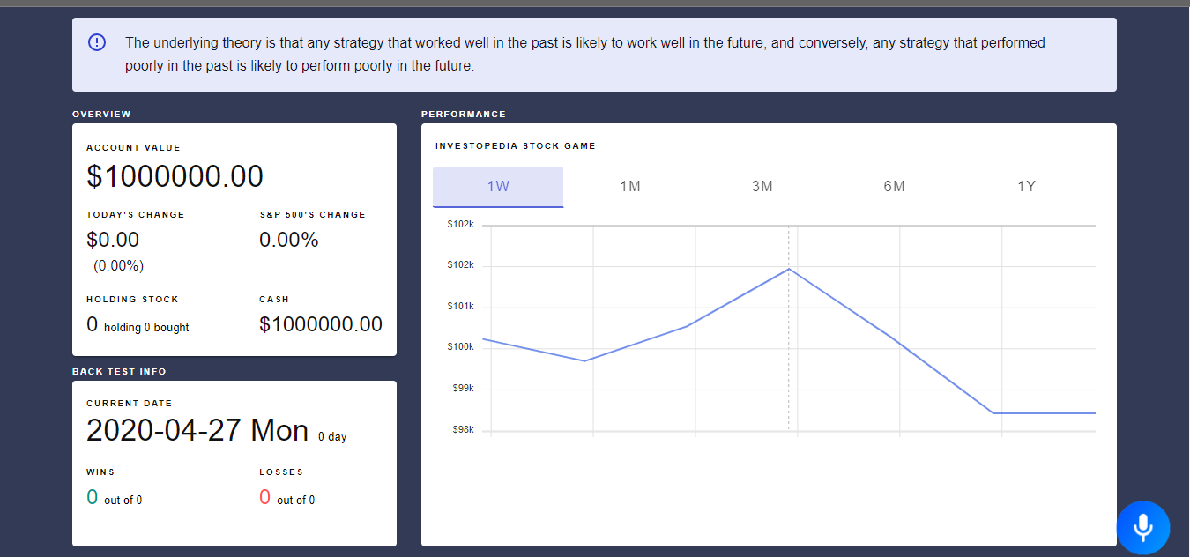

Figure 28 Back-testing page

* Yahoo finance Chart popup window

Chart popup window will open when a user commands to open a chart. I used the yahoo finance’s chart.

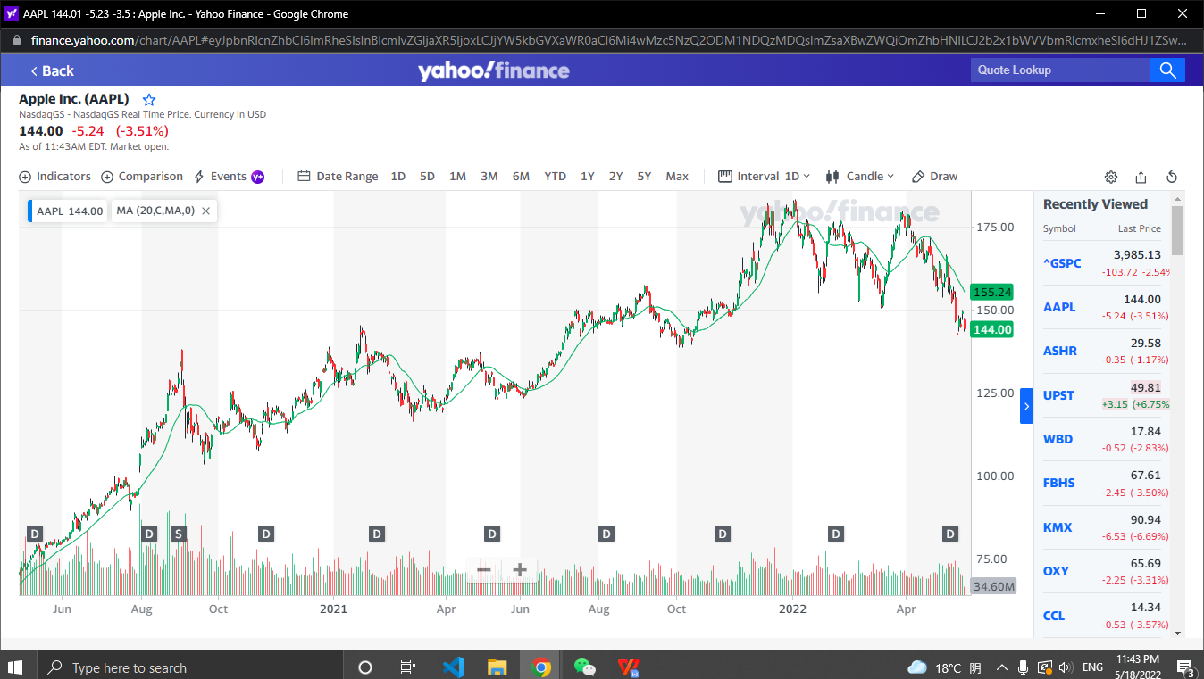

Figure 29 chart popup window

* News detail popup window

A user can view more details about an article by commanding Finansis to open details page for the article.

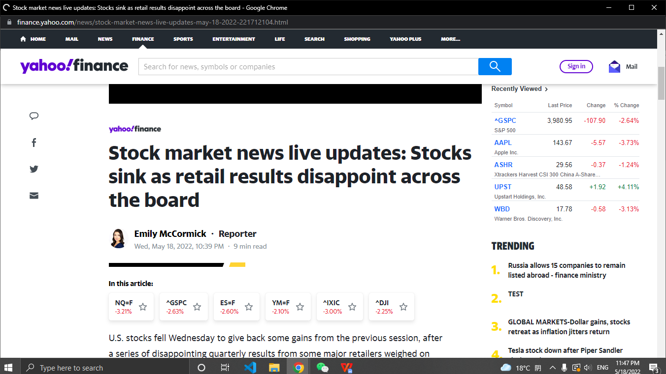

Figure 30 News detail popup window

* Finansis Button

Finansis button helps a user to know which state Finansis currently, it contains 3 state: deactivate, speaking and listening. It also activate and deactivate Finansis when clicking on it.



Figure 31 Finansis Button

## Commands implementation

In this sections you will find the most import commands implementation: Give me the news from {source}, Open {symbol|company name} chart and start back-testing.

* Give me the news from {source}

Create the command by a signing possible commands to ‘command’ key and signing news handler function (getNews) to callback key in which will be called when for example a user command ‘give me the news from yahoo finance’ and pass ‘giveMeSource’ as first parameter and ‘yahoo finance’ as second parameter:

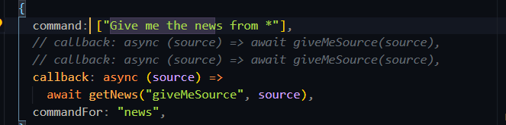

Import NEWS_API_URL_C from serverUtils file to get news API URL:

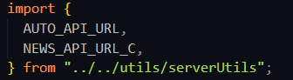

serverUtils file:

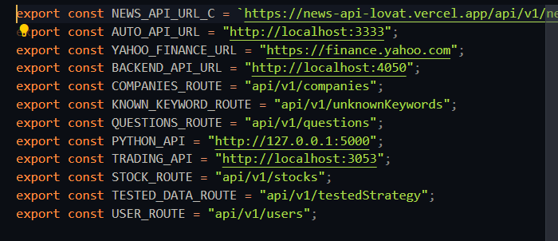

Tell a user ‘finding’ and then set NEWS_API_URL to NEWS_API_URL_C, I create NEWS_API_URL because I want to update news API URL:.

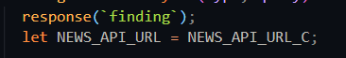

Check if the type equal ‘giveMeMore’, in this case the type equal ‘giveMeSource’ so just ignore the following code:

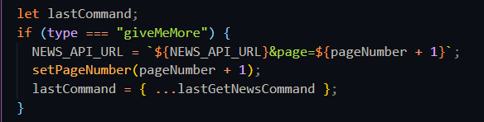

Check what type of news to Fetch from news API, in this case it is getting news by source because the type equal ‘giveMeSource’ so set localQuery to ‘yahoo finance’ and then update NEWS_API_URL by adding ‘&source=yahoo finance&sortBy=publishedAt’ and then save ‘giveMeSource’ type and ‘yahoo finance’ query in lastGetNewsCommand state to use it later for ‘give me more news’ command.

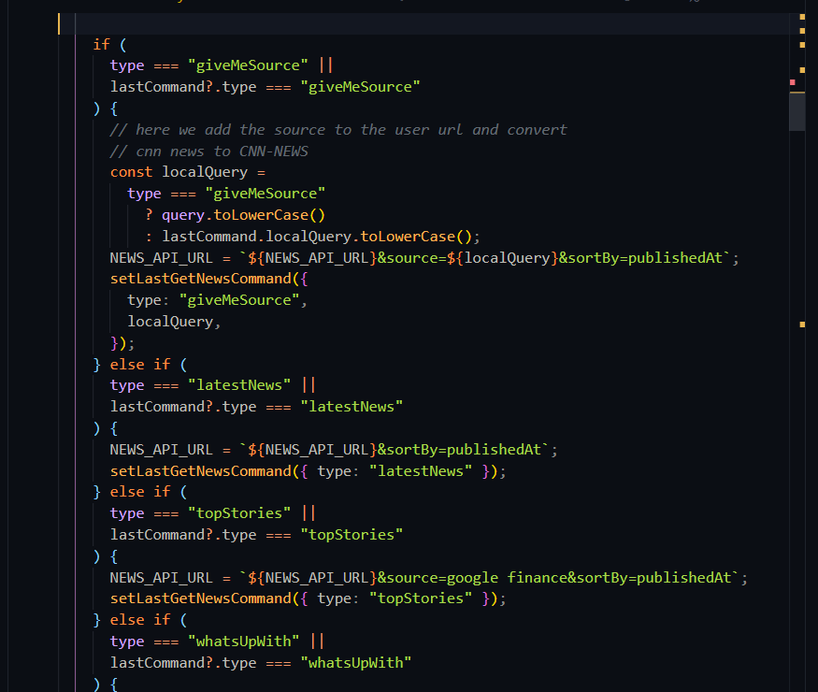

Send a request to news API and then after the request sent successfully , save articles and isExist data in variable:

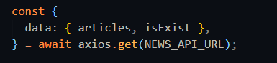

Set newsAricles to articles variable if type not equal ‘giveMeMore’ and isExist equal true :

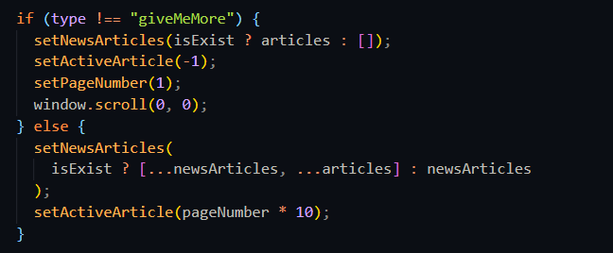

Create responsePositiveOrNegative helper function, this function is for letting Finansis respond a positive response if isExist equal true otherwise respond a negative response:

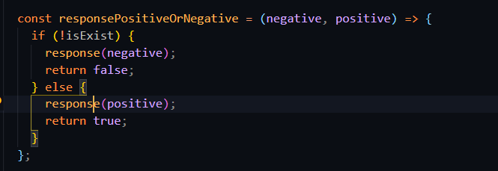

Let Finansis response based on type parameter and isExist variable, in this case Finansis will response ‘here is the news from yahoo finance’:

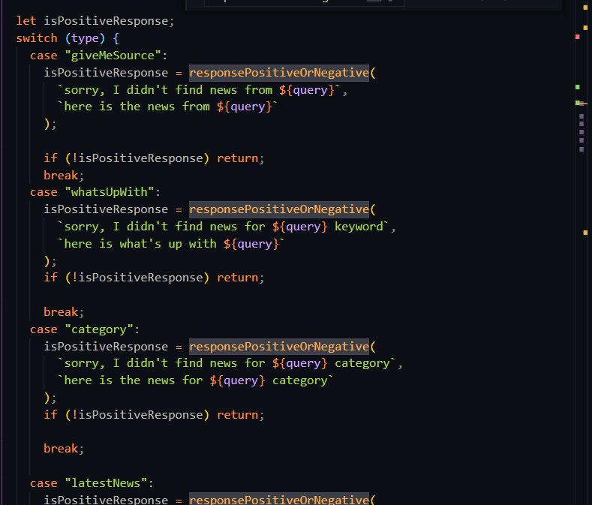

Let Finansis ask a user ‘do you want me to read the head lines’, and then set secondCommandFor equal to ‘readThHeadLines”:

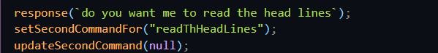

* Open {symbol|company name} chart

Create the command by a signing possible commands to ‘command’ key and signing open yahoo finance function handler (openYahooFinance) to callback key in which will be called when for example a user command ‘open Apple chart’ and pass ‘chart’ as first parameter and ‘Apple’ as second parameter:

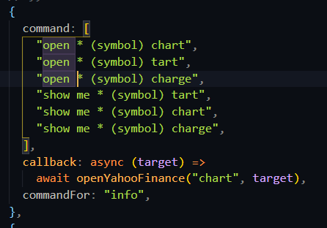

Set finalTarget to target after trimming it, and then call lookupForTickersV2 function and pass finalTarget ad first parameter:

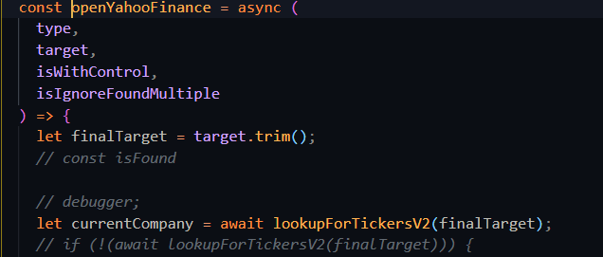

In lookupForTickersV2 send request to back-end API with symbol=Apple as query string to fetch companies with ‘Apple’ symbol, in this case the request will return an error so lookupForTickersV2 function will return null:

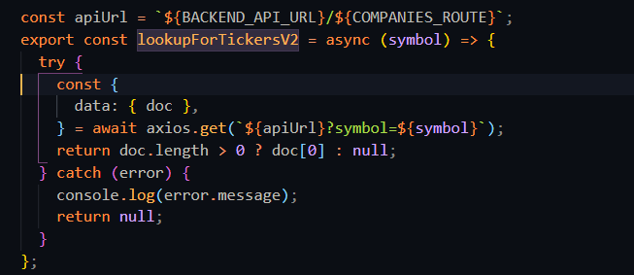

GetCompanies handler in back-end API, check if name exist in the request query object, in this case it is not exist, check if symbol exist in the request query object, in this case it is exist so set queryObject.symbol to ‘apple’:

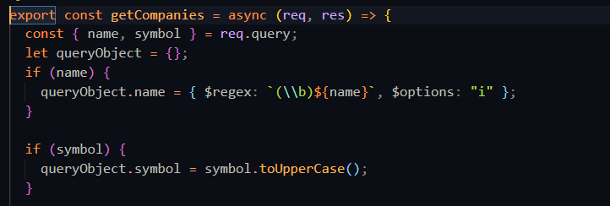

Fetch companies with ‘apple’ symbol from MongoDB and a sign the result to companies variable:



Check if companies.length not equal zero, if it is not equal zero respond with a successful response, otherwise respond with a fail response, in this case it will be a fail response:

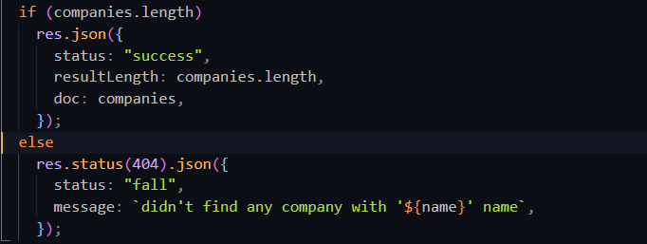

Check if currentCompany not null, if currentCompany equal null so then call searchCompanyNamV2 and then sign symbolsFound to the return value:

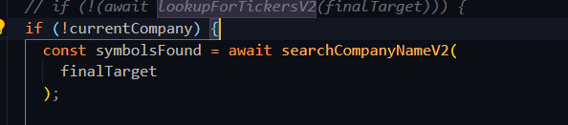

In searchCompanyNameV2 send request to back-end API with name=Apple as query string to fetch companies that has ‘Apple’ keyword in their name, in this case the request will return multiple companies:

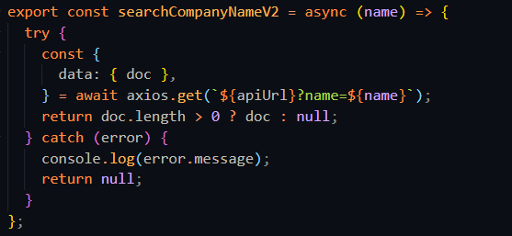

Check symbolsFuund array contains multiple companies, in this case it contains multiple companies so then check if isIgonerFundMultiple is equal true which doesn’t equal in this case so then call setFundMultiple function:

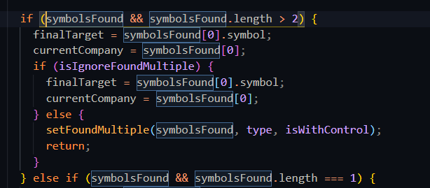

In setFoundMultiple helper function, first tell a user ‘found the following stocks choose one by saying stock number 3 for example’, second open info modal by passing “found the following stocks” as first parameter and found companies as second parameter, third save window type in state and lastly save found stocks as parameter:

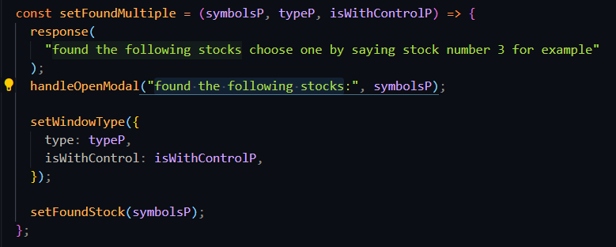

Handle a user chose using ‘stock (number) *’ command. After a user choose a stock fundMultipleStocks function will be called and the number that has been chosen by the user will pass to the function:

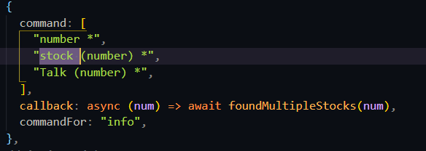

Convert a word number to a number:

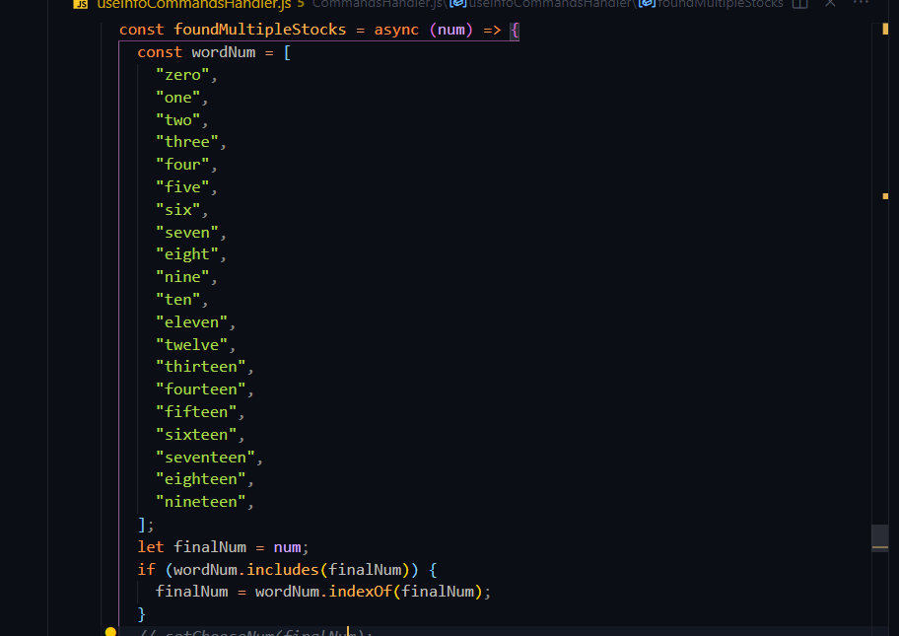

Check if a user chose a valid number and if it is so then save chosen symbol in symbol variable and close info modal:

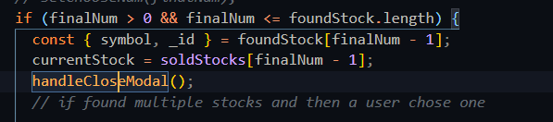

Call yahooFinanceOpeningWResponses helper function and pass windowType which is chart in this case as first parameter and chose symbol as second parameter:

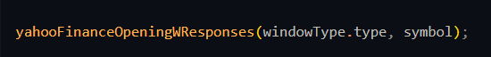

In yahooFinanceOpeningWResponses Let Finansis respond based on window type, in this case it is chart so the response is ‘opening AAPL chart’

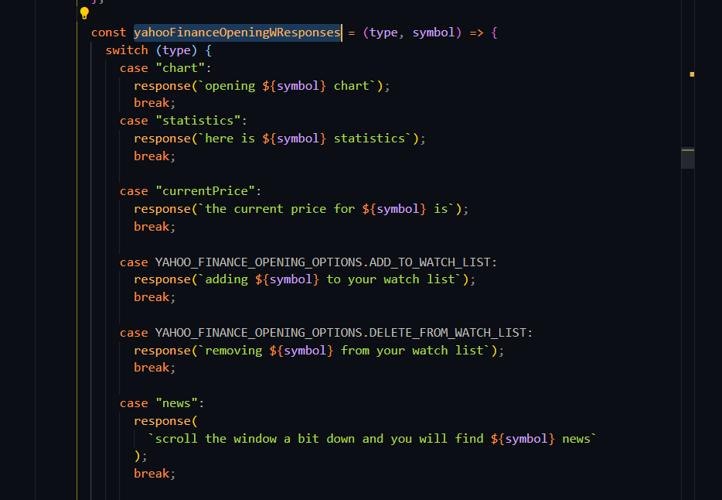

Check if window will open with Finansis control or not, in this case is not so call openWindow function and pass ‘chart’ as first parameter and ‘AAPL’ as second:

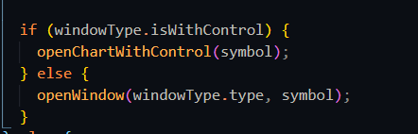

In openWindow function open yahoo finance chart using window.open:

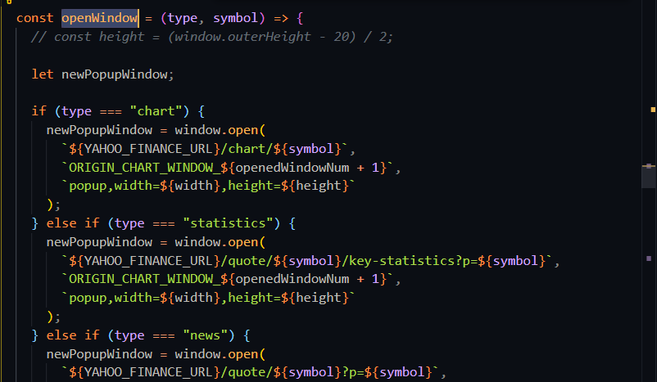

save instant of opened window as state to close it later and save the current number of opened window:

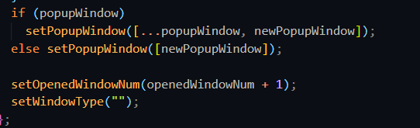

* start back testing

Create the command by a signing possible commands to ‘command’ key and signing start back testing function handler (startBackTesting) to ‘callback’ key in which will be called when a user command ‘start back testing’:

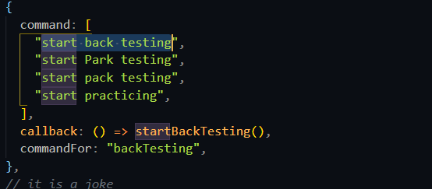

In startBackTesting function check if a user have tested data stored in his localStorage in this case the user doesn’t have tested data so call getBTInput function and pass cash label as first parameter and cash message as second parameter, cash message is for Finansis response:

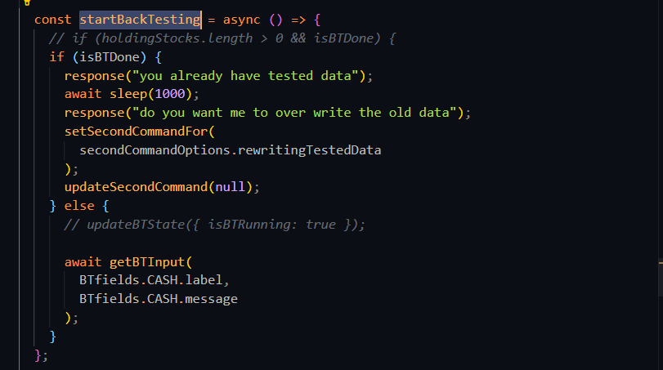

In getBTInput helper function let Finansis respond with the message and then stop the

Function for 1 second and lastly open inputModal by calling handleOPenModal helper function:

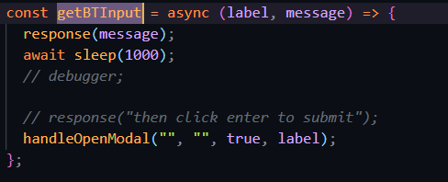

handlerOpenModal has four parameter, the first is the title of the modal, the second is the content, the fourth is isInput, it is boolean value to determine what type modal to open and lastly label for the input:

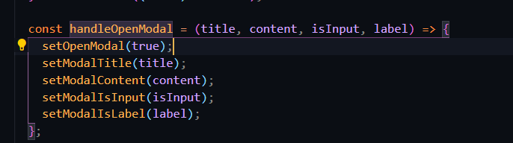

Call useHandleUserInput custom hook:

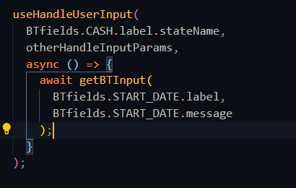

useHandlerUserInput custom hook for setting event listing when a user finish inputting, it has three parameters, unique field name, other parameters object and callback function that will be called when the event has been targeted:

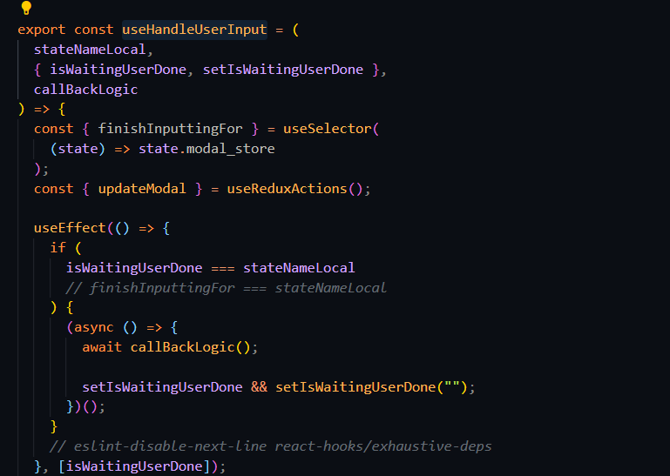

After a user input start date and account risk and end data successfully, so then tell a user ‘starting back testing’, and then call getTestedData function after the testing is done tell ‘back testing is done’ and set isForForceSell to true to check for stocks to force sell:

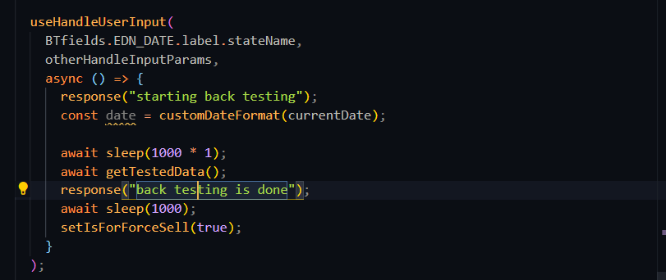

In getTestedData function, call backTestMain function and pass endData entered by the user and the same function as second parameter to called recursively:

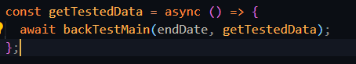

backTestMain function has four parameter the end date of back-testing, function to call recursively, a flag for force sell and a flag sell with profit or without, in this case isForceSell is undefined and isWithProfitOrNot is also undefined, in this function first update isBTRunning state to true, second check if the type of currentDateLocal is string if it is so then change to Date:

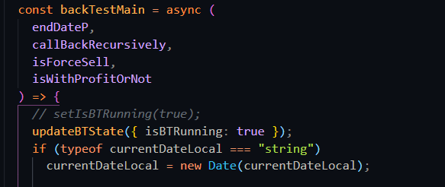

Check if start date is smaller then or equal end date,ignore the first condition, it is for force sell only:

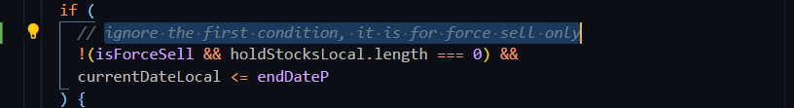

Format the start date as year-month-day:



Call handleBackTestingAxiosError and pass checkIsMarketOpen function and date and an error message:

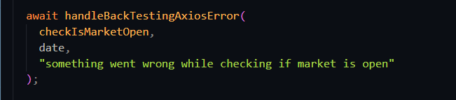

checkIsMarketOpen function is for sending request to ‘isMarketOpen’ endpoint in trading API and saving the value returned from the request:

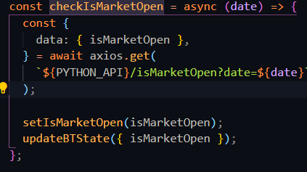

‘isMarketOpen’ endpoint:

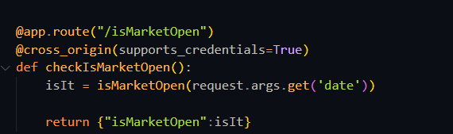

handleBackTestingAxiosError function is for handling errors from Trading API and making sure that each request has been sent successfully by creating while loop that it will break only when the request sent successfully:

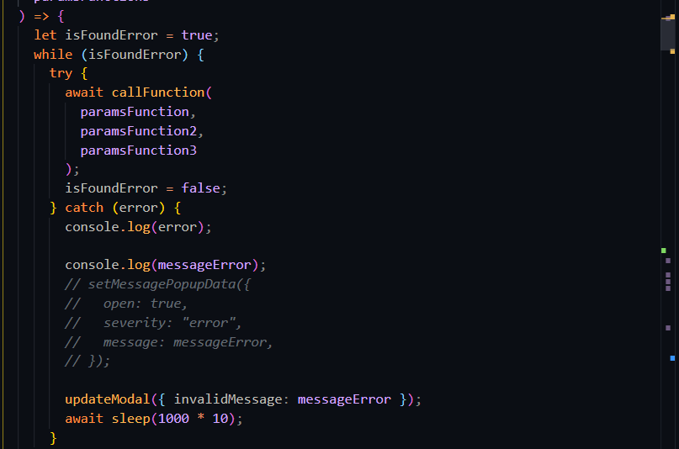

Back in backTestMain, check if a user holding stocks:

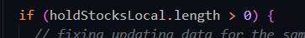

Call handleBackTestingAxiosError function again but this time pass getSp500Date function:

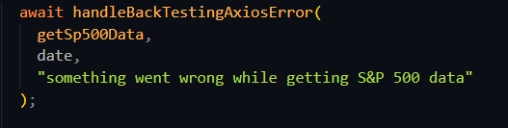

getSp500Date function is for sending request to ‘getSP500Date’ endpoint in trading API and saving s&p 500 data:

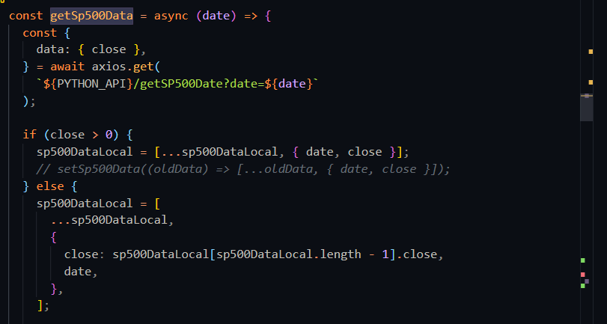

‘getSP500Date’ endpoint:

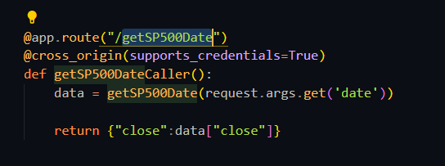

Back in backTestMain, and the same process as getSp500Date for updateCurrentPrice and sell:

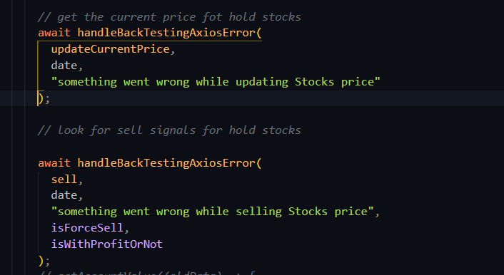

Call handleBackTestingAxiosError and pass buy function, if isForceSell not true:

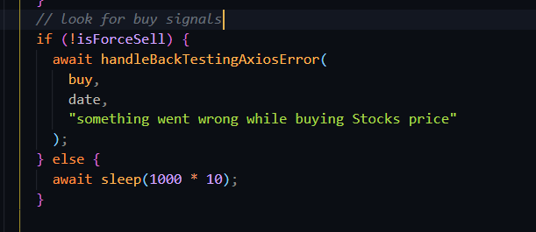

Update back-testing date:

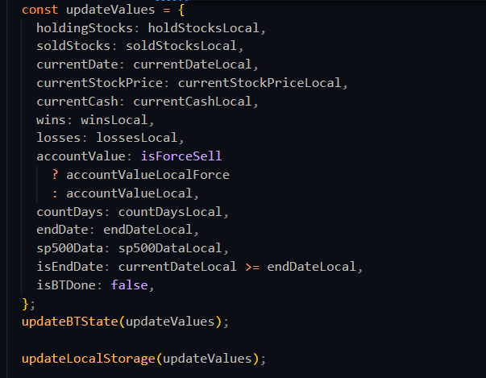

Lastly repeat the above process recursively until state date smaller then or equal end date:

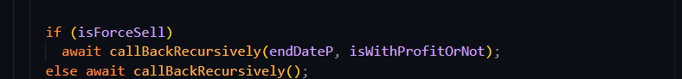

# Testing

Software Testing is a method to check whether the actual software product matches expected requirements and to ensure that software product is Defect free. It involves execution of software/system components using manual or automated tools to evaluate one or more properties of interest. The purpose of software testing is to identify errors, gaps or missing requirements in contrast to actual requirements.

In this project I used manual testing.

* **Test case ID**

T1

* **Test case title**

Validate getting news by source successfully

* **Test steps**

- command ‘Give me the news from {yahoo finances}’

* **Test data**

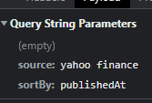

Figure 32 T1 test data

* **Expected result**

Responding ‘finding’

Showing a user news from Yahoo Finances

Responding ‘here is the news from Yahoo Finances’

Asking ‘do you want me to read the head lines’

* **Actual result**

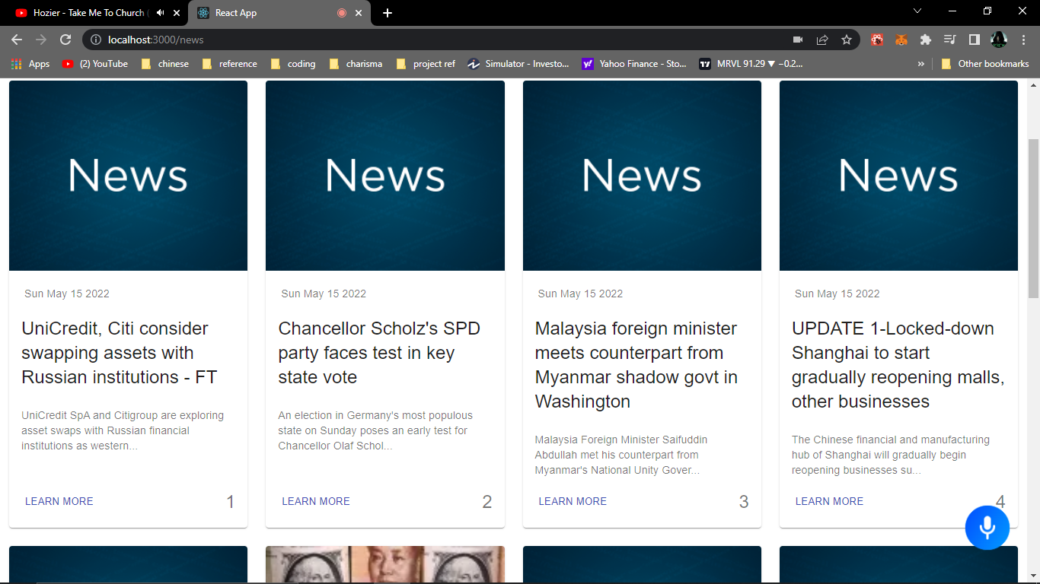

Figure 33 T1 showing news

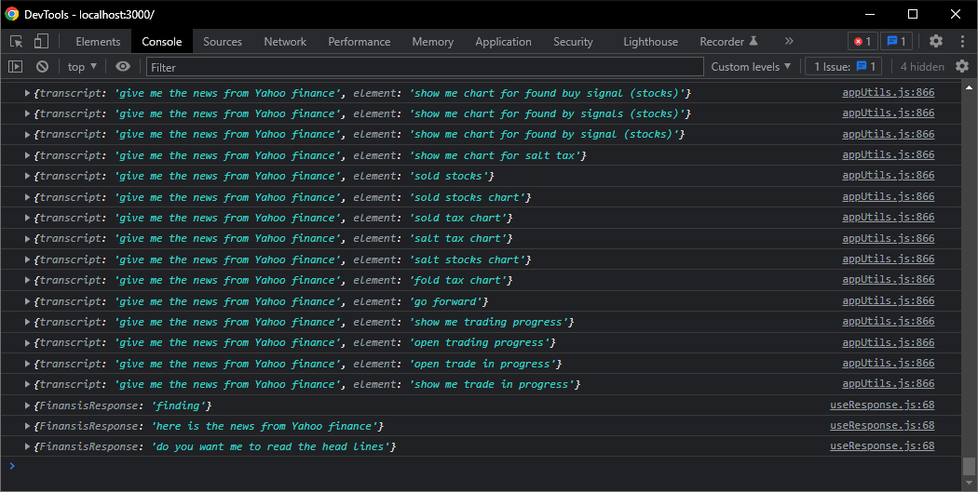

Figure 34 T1 Finansis response

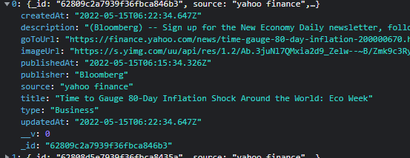

Figure 35 T1 Response from the API

* **Conclusion**

**Pass**

* **Test case ID**

T2

* **Test case title**

Validate getting news by source Failing

* **Test steps**

- command ‘Give me the news from {CNN}’

* **Test data**

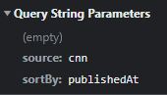

Figure 36 T2 Test data

* **Expected result**

Responding ‘finding’

Responding ‘sorry, I didn't find news from {CNN}’

* **Actual result**

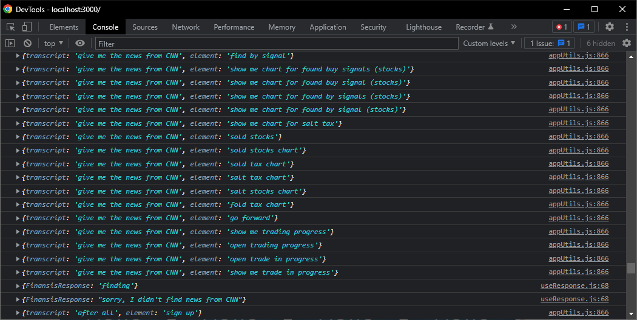

Figure 37 T2 Finansis response

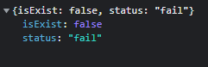

Figure 38 T2 response from the API

* **Conclusion**

**Pass**

* **Test case ID**

T3

* **Test case title**

Validate getting news by keyword in Title successfully

* **Test steps**

- command ‘what's up with {Shanghai}’

* **Test data**

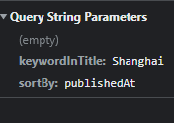

Figure 39 T3 Test data

* **Expected result**

Responding ‘finding’

Showing a user news that has ‘Shanghai’ keyword in the head line

Responding ‘here is what's up with Shanghai’

Asking ‘do you want me to read the head lines’

* **Actual result**

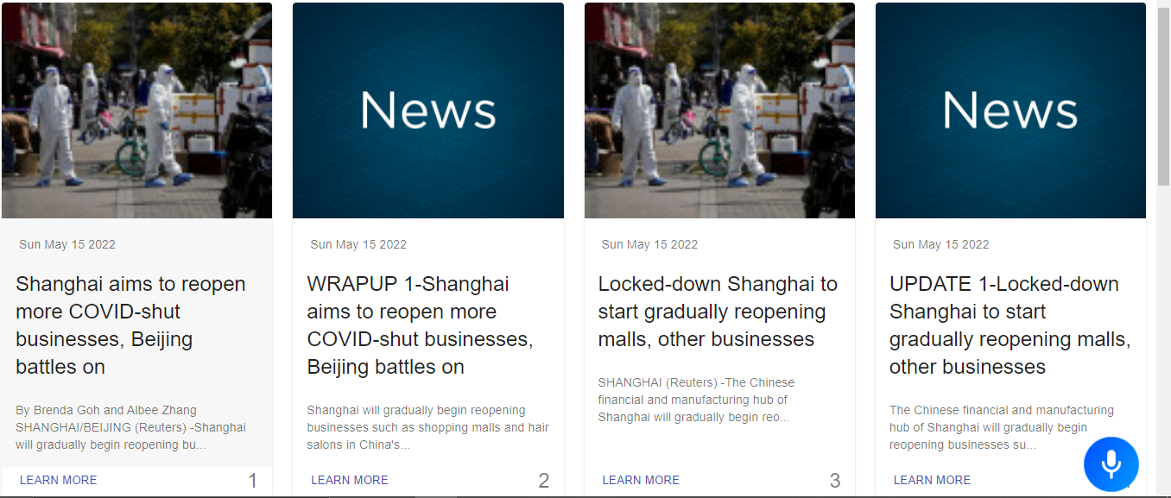

Figure 40 T3 showing News

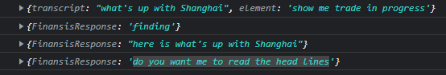

Figure 41 T3 Finansis response

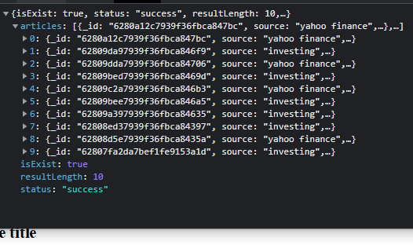

Figure 42 T3 response from the API

* **Conclusion**

**Pass**

* **Test case ID**

T4

* **Test case title**

Validate asking question in the database

* **Test steps**

- ask ‘what is market capitalization’

* **Test data**

what is market capitalization

* **Expected result**

- Opening popup window with the answer

- Responding ‘Market capitalization refers to how much a company is worth as determined by the stock market. It is defined as the total market value of all outstanding shares. value of all outstanding shares.’

- Closing popup window after answering the question

* **Actual result**

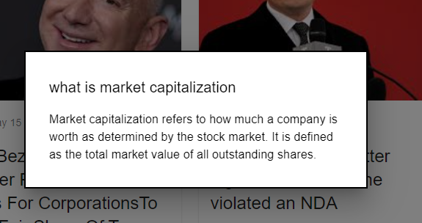

Figure 43 T4 showing the answer

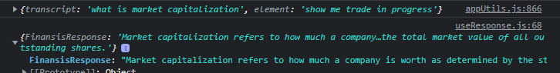

Figure 44 T4 Finansis Response

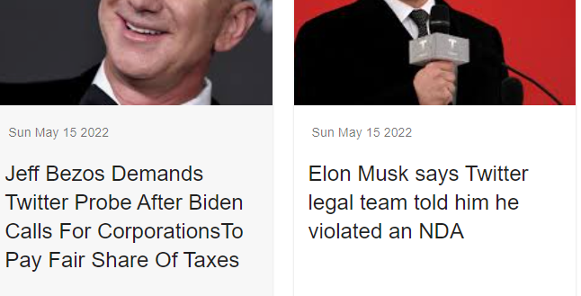

Figure 45 T4 closed popup window

* **Conclusion**

**Pass**

* **Test case ID**

T5

* **Test case title**

Validate asking question not in the database

* **Test steps**

- ask ‘what is price-to-earning ratio’

* **Test data**

what is price-to-earning ratio

* **Expected result**

asking ‘do you want me to learn about what is price-to-earning ratio’

* **Actual result**



Figure 46 T5 Finansis Response

* **Conclusion**

**Pass**

* **Test case ID**

T6

* **Test case title**

Validate ‘yes’ answer for ‘do you want me to learn about what is price-to-earning ratio’ question

* **Test steps**

- answer ‘Yes’

* **Test data**

Yes

* **Expected result**

- Responding ‘give me a minute to find an answer’

- opening DuckDuckGo search engine using puppeteer

- searching ‘what is price-to-earning ratio investopedia’

- clicking at the first result

- scrap the answer from investopedia website

- save the question in the database

- Opening popup window with the answer

- Answering the question

- Closing popup window after answering the question

* **Actual result**

Before searching for an answer:

MongoDB:

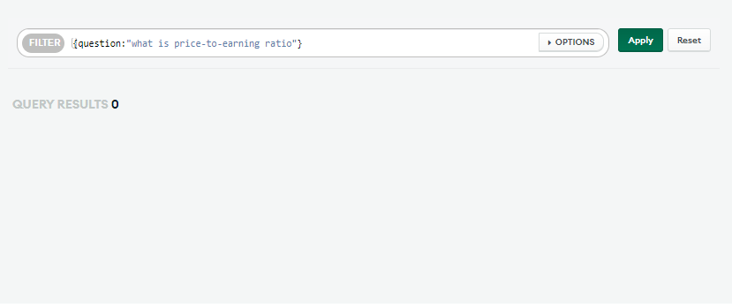

Figure 47 T6 MongoDB result before searching



Figure 48 T6 Finansis Response

Sending request to AUTO API’s ‘FindingAnswers endpoint”:

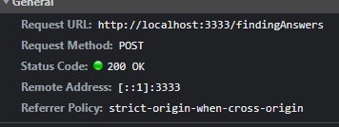

Figure 49 T6 sending request to Auto API

Searching in DuckDuckGo:

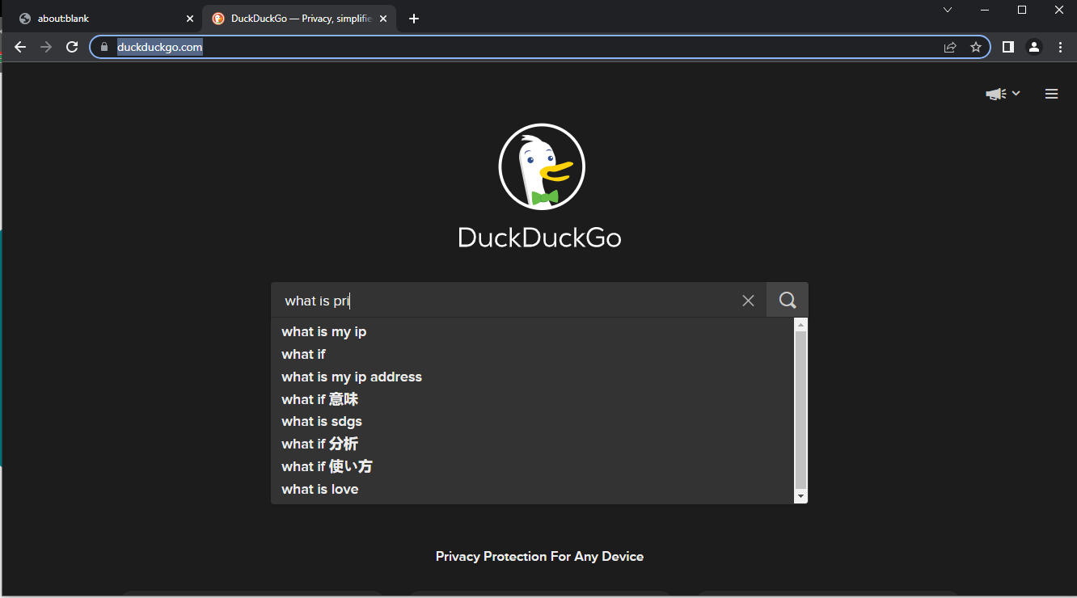

Figure 50 T6 searching in DuckDuckGo

After searching for an answer:

Response from AUTO API:

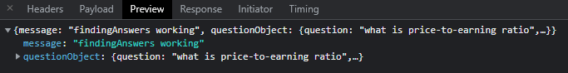

Figure 51 T6 response from auto API

MongoDB:

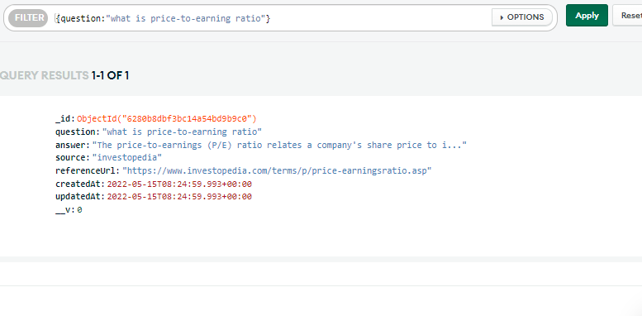

Figure 52 T6 MongoDB result after searching

Opening popup window with the answer:

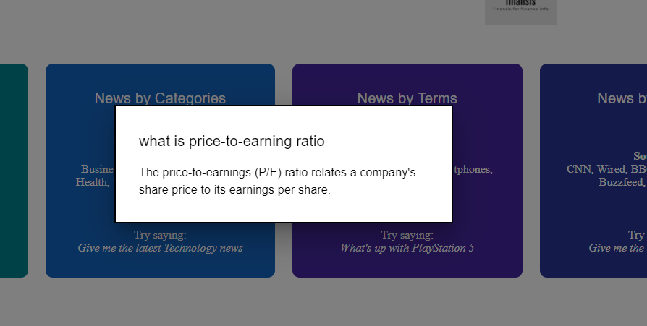

Figure 53 T6 showing the answer



Figure 54 T6 Finansis response

* **Conclusion**

Pass

* **Test case ID**

T7

* **Test case title**

Validate opening chart successfully

* **Test steps**

- command ‘open Apple chart’

* **Test data**

open Apple chart

* **Expected result**

- Opening popup window with list of stocks

- Asking ‘found the following stocks choose one by saying stock number 3 for example’

- Responding ‘opening AAPL chart’

* **Actual result**

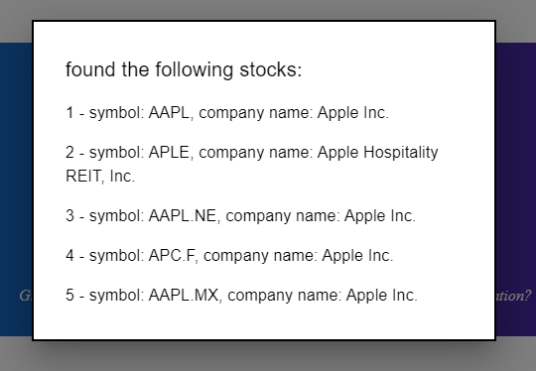

Figure 55 T7 Finansis opening popup to let a user choose a stock



Figure 56 T7 Finansis asking

After a user chose a stock:



Figure 57 T7 Finansis response

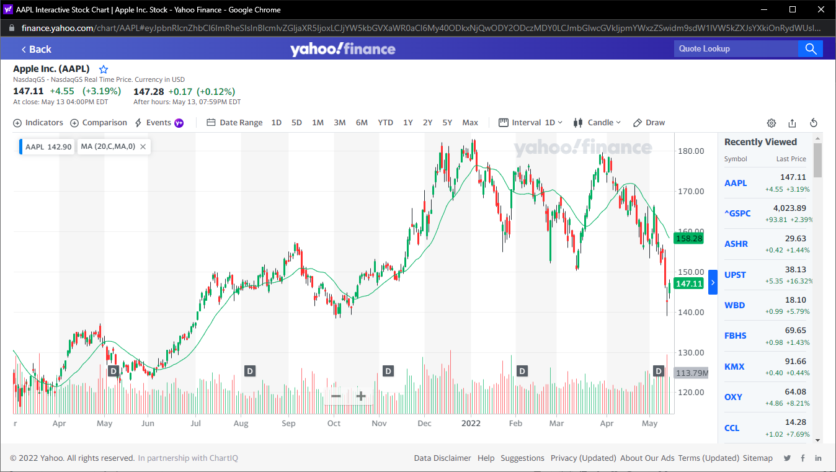

Figure 58 T7 opening the chart

* **Conclusion**

pass

* **Test case ID**

T8

* **Test case title**

Validate opening multiple successfully

* **Test steps**

- command ‘open Apple and Tesla charts’

* **Test data**

open Apple and Tesla charts

* **Expected result**

- Responding ‘opening Apple chart’

- Opening Apple chart

- Responding ‘opening Tesla chart’

- Opening Tesla chart

* **Actual result**



Figure 59 T8 Finansis response

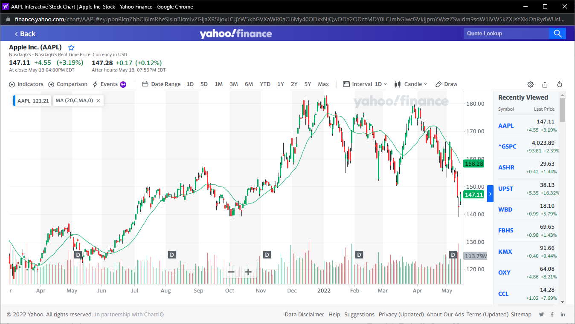

Figure 60 T8 opening Apple chart



Figure 61 T8 Finansis Response

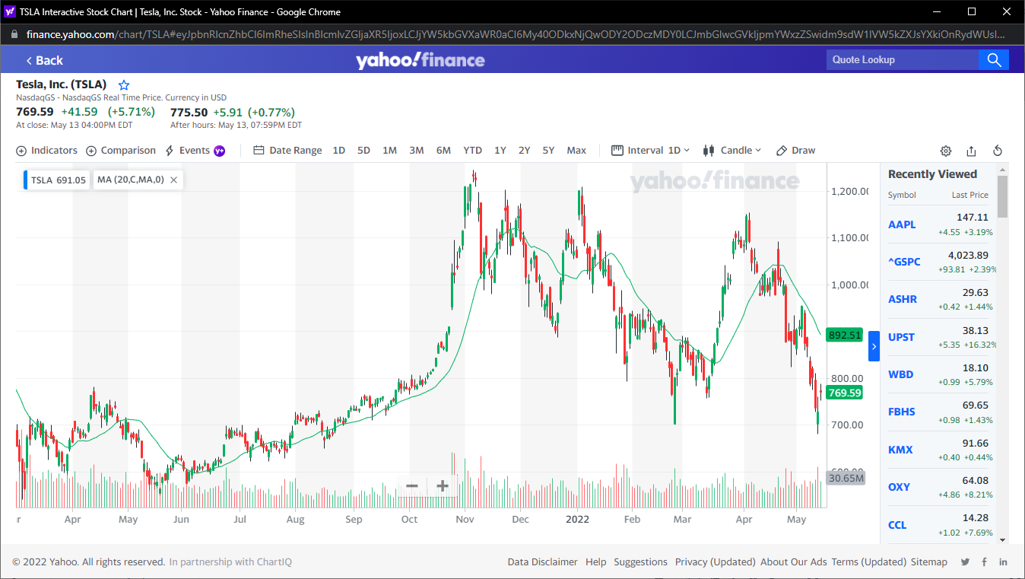

Figure 62 T8 opening Tesla Chart

* **Conclusion**

pass

* **Test case ID**

T9

* **Test case title**

Validate opening chart with Finansis control successfully

* **Test steps**

- command ‘open apple Chart with your control’

* **Expected result**

- Opening popup window with list of stocks

- Asking ‘found the following stocks choose one by saying stock number 3 for example’

- Responding ‘opening AAPL chart’

- Responding “loading the page will take seconds”

Opening AAPL chart using puppeteer

- Responding “the page is done loading”

* **Actual result**

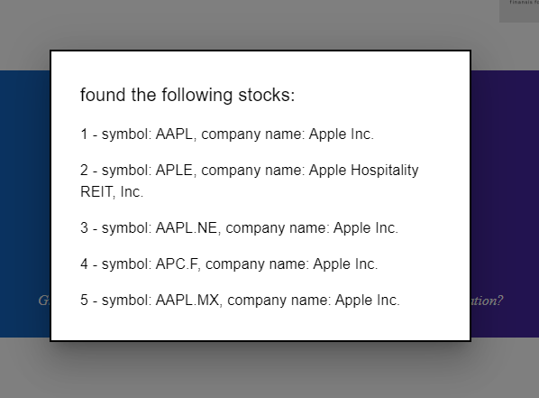

Figure 63 T9 Finansis opening popup to let a user choose a stock



Figure 64 T9 Finansis asking

After a user chose a stock:

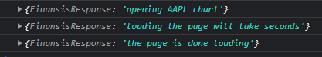

Figure 65 T9 Finansis response

Send request to Auto API with the following payload:

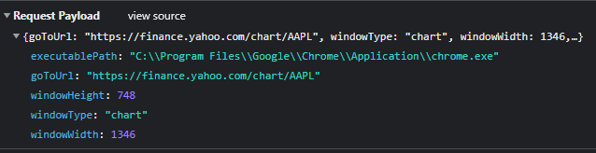

Figure 66 T9 sending a request to Auto API

Opening chart window using puppeteer:

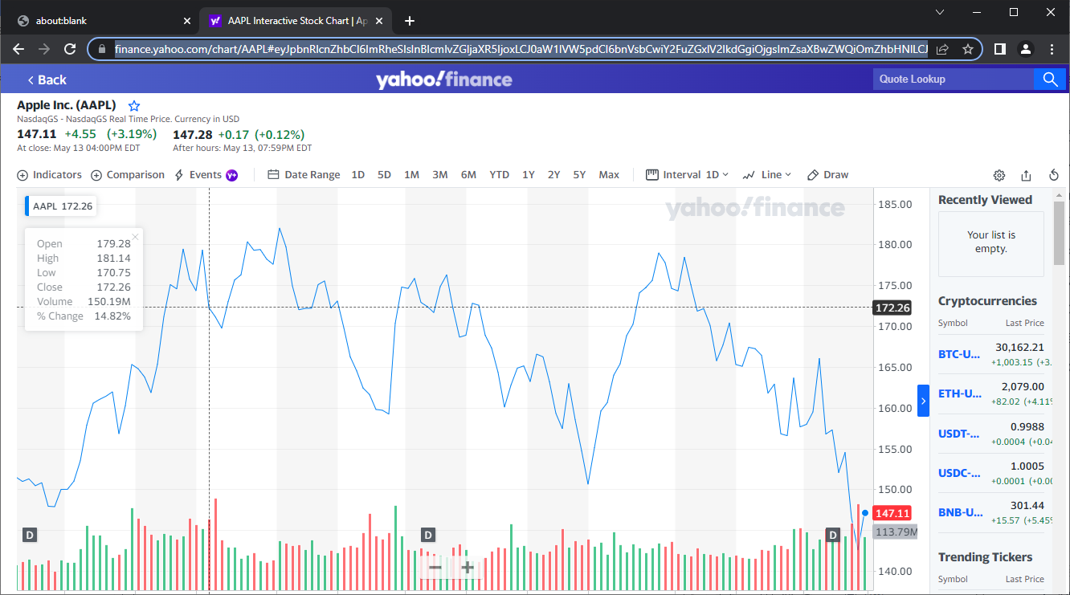

Figure 67 T9 opening the chart using puppeteer

* **Conclusion**

pass

* **Test case ID**

T10

* **Test case title**

Validate back-testing successfully

* **Test steps**

- command ‘start pack testing’

* **Test data**

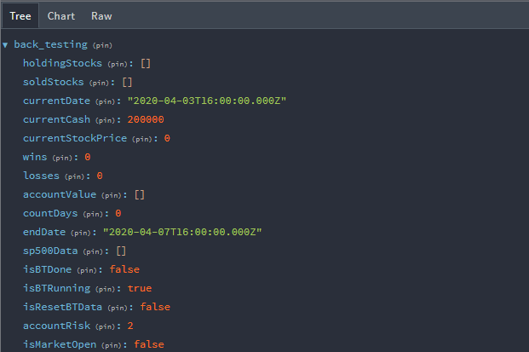

Figure 68 T10 test data

Google finance only shows top news by default

* **Expected result**

- Responding ‘enter initial cash’

- Opening input model to let a user enter initial cash

- closing popup window

- Responding ‘enter start date’

- Opening input model to let a user enter start date

- closing popup window

- Responding ‘enter percentage of account risk per trade’

- Opening input model to let a user enter start date

- closing popup window

- Responding ‘enter end date’

- Opening input model to let a user enter start date

- closing popup window

- Responding ‘starting back testing’

- start back testing

Responding ‘back testing is done’

If there are stock haven’t sold Asking ‘do you want me to force sell’

* **Actual result**

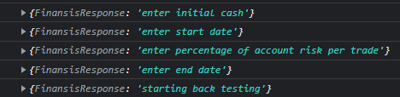

Figure 69 T10 Finansis Response

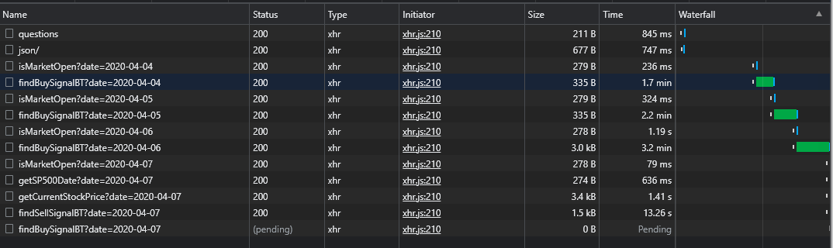

Figure 70 T10 requests sent to trading API

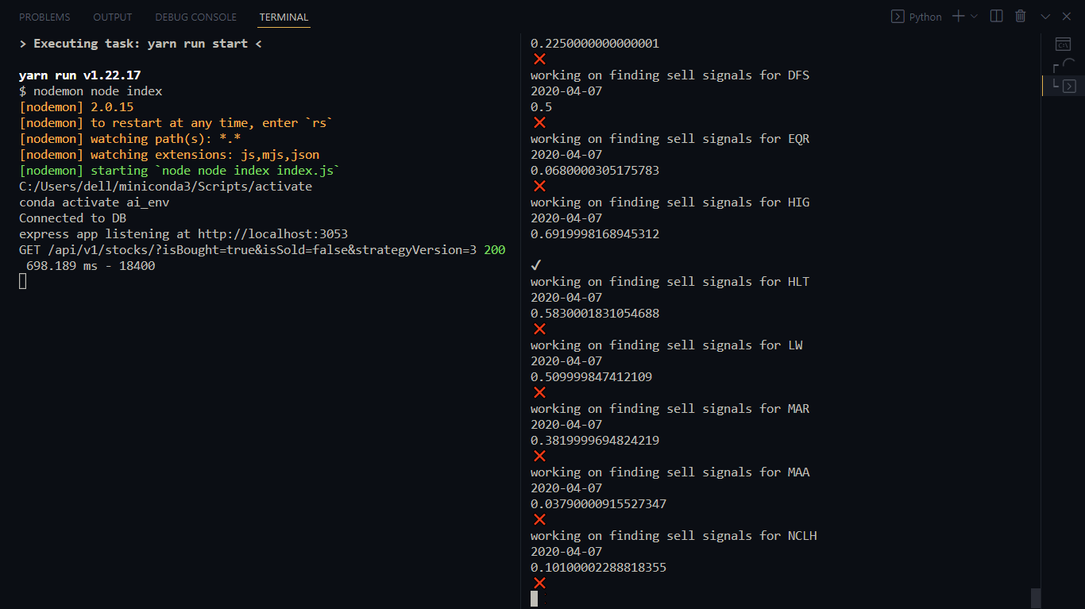

Figure 71 T10 Trading API logs

After finishing back-testing:

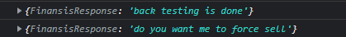

Figure 72 T10 Finansis response

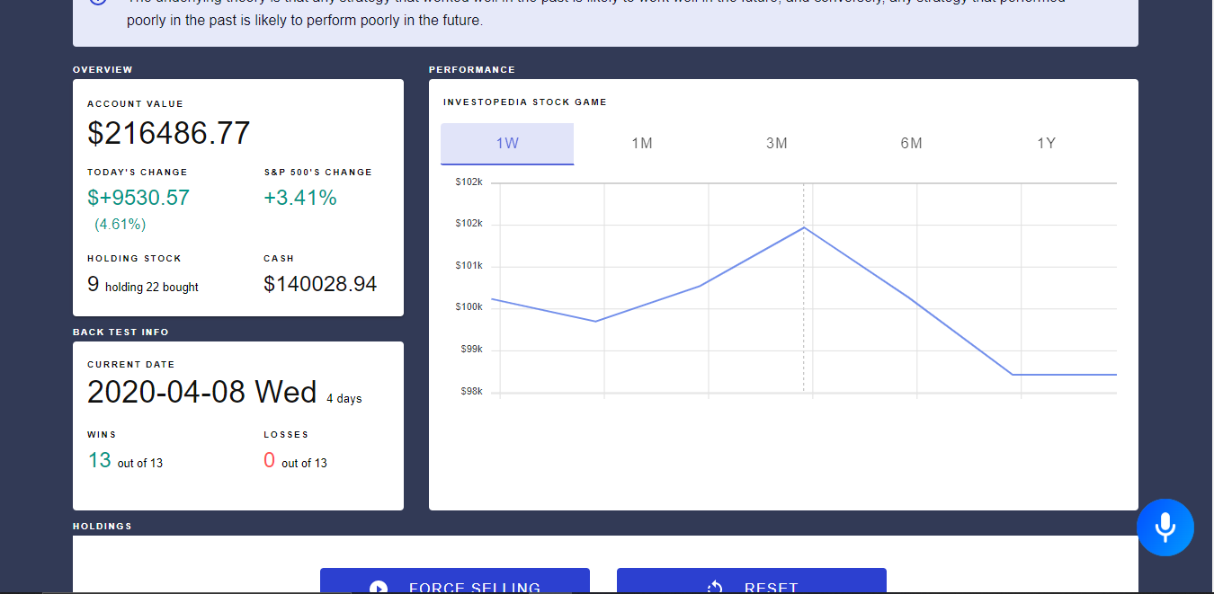

Figure 73 T10 final result

* **Conclusion**

**Pass**

* **Test case ID**

T11

* **Test case title**

Validate buy stocks successfully

* **Test steps**

- command ‘buy stocks’

* **Test data**

Buy stocks

* **Expected result**

Responding ‘getting s&p 500 stocks’

Sending request to ‘save s&p 500 stocks’ endpoint in trading API

Responding ‘S and P 500 stocks saved successfully’

Responding ‘Finding buy signals’

Sending request to ‘find buy signals’ endpoint in trading API

Responding ‘Finding buy signals’

Responding ‘found {the number of bought stocks} buying signals’

Responding ‘buying stocks’

Opening Investopedia simulator using puppeteer to automate buy stocks

* **Actual result**



Figure 74 T11 Finansis response

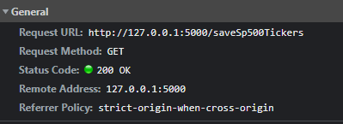

Figure 75 T11 sending request

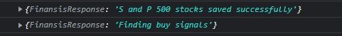

Figure 76 T11 Finansis response

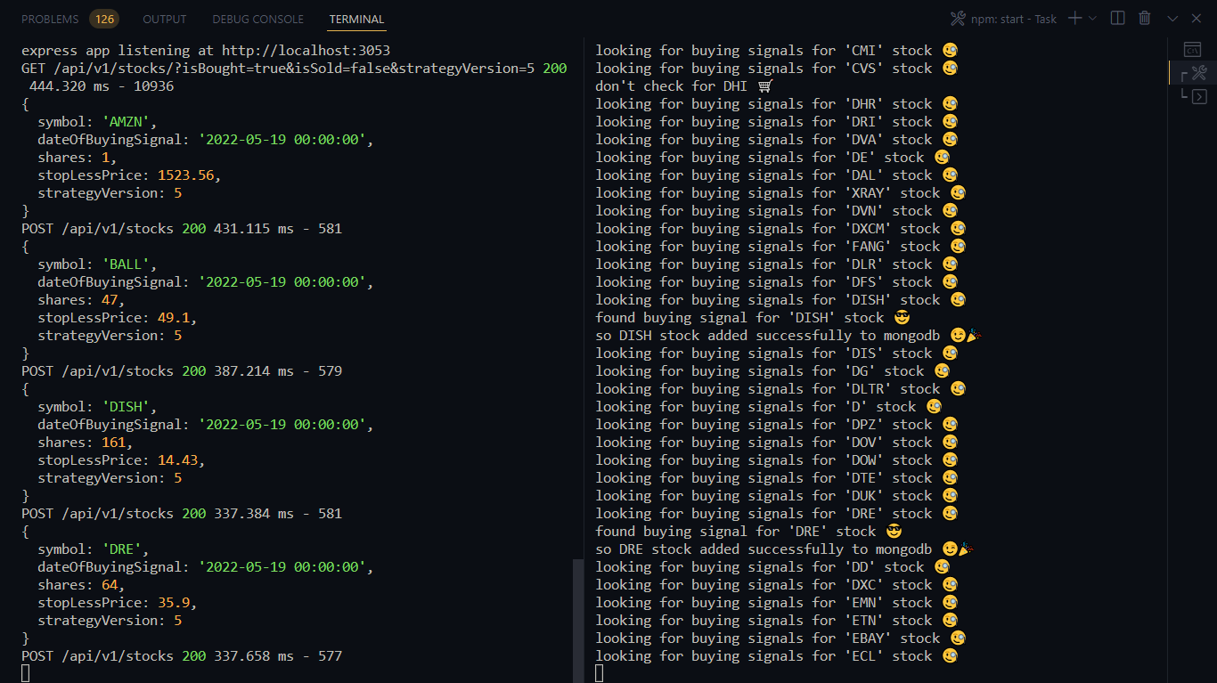

Figure 77 T11 trading API logs

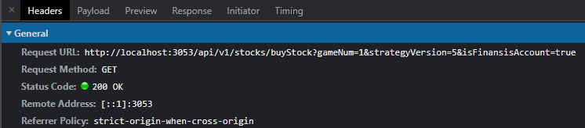

Figure 78 T11 sending request to trading API

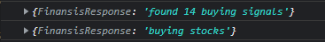

Figure 79 T11 Finansis response

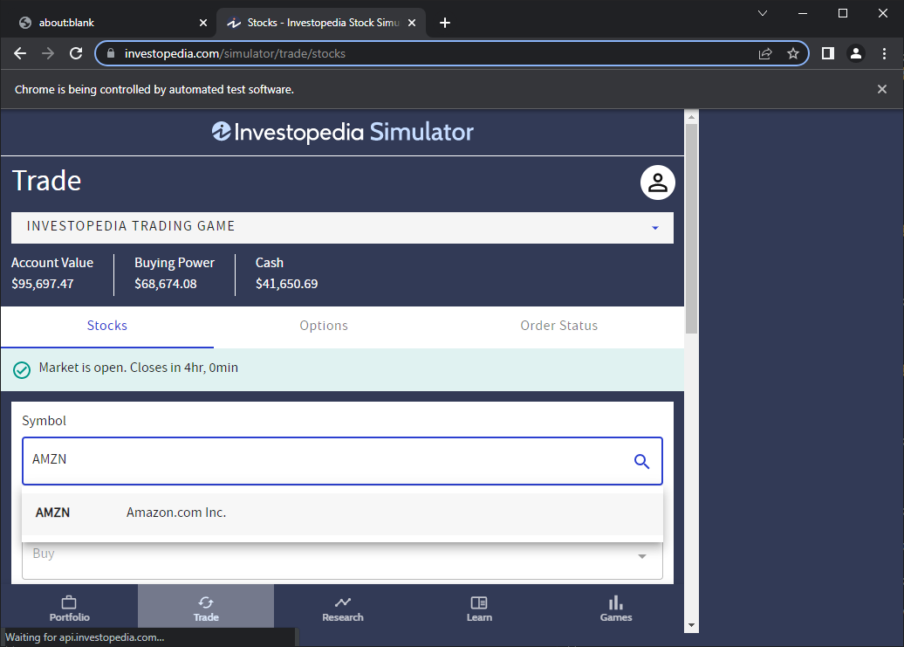

Figure 80 T11 automate buy stocks

* **Conclusion**

**pass**

* **Test case ID**

T12

* **Test case title**

Validate sell stocks successfully

* **Test steps**

- command ‘sell stocks’

* **Test data**

No data

* **Expected result**

Responding ‘checking for sell signals’

Sending request to ‘find sell signals’ endpoint in trading API

Responding ‘found{the number of bought stocks} sell signals’

Responding ‘selling stocks’

Sending request to ‘sell stock’ endpoint in auto API

Opening Investopedia simulator using puppeteer to automate sell stocks

Responding ‘the following stocks has been sold: symbol: {symbols}, ’

* **Actual result**



Figure 81 T12 Finansis Response

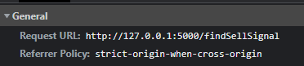

Figure 82 T12 send request

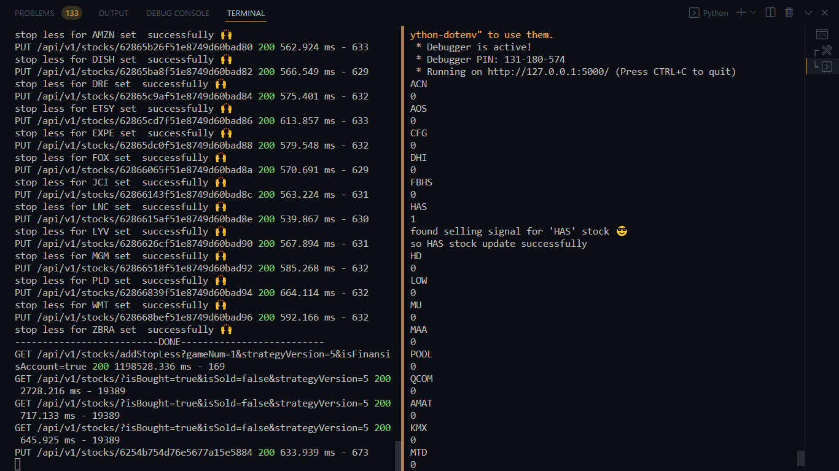

Figure 83 T12 trading API logs

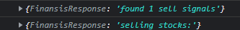

Figure 84 T12 Finansis Response

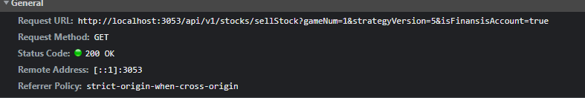

Figure 85 T12 send request

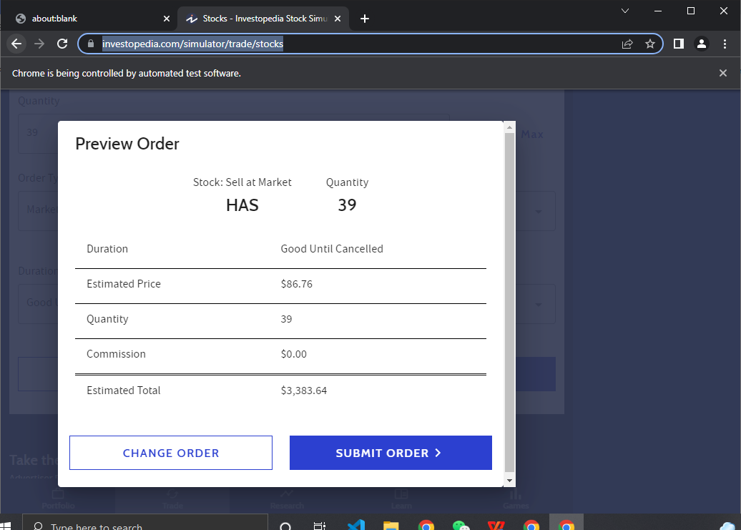

Figure 86 T12 automating sell stocks



Figure 87 T12 Finansis Response

* **Conclusion**

**pass**

# Conclusion

Thanks to every teacher who taught me something about computer science in Wenzhou or on the internet, thanks to each programmer on StackOverflow that help me or build technologies I used in this project, and special thanks to Wingo Laoshi that help me to come up with Finansis idea by telling me my old idea is not reasonable which was creating 'stock market production model' using machine learning. I will keep working on this project, and keep researching for good developers to build and improve the project, and one day we will take Finansis project from a final project for Degree of Bachelor to a real business that anyone interested in the stock market or making passive income can use Finansis.

## Future Goals For The System overview

* Improving UI design.
* Trading stocks with real money.
* Making the System online.
* Creating our own voice Recognition AI.
* Adding more commands to control the System.
* Making Finansis understand other Languages (Arabic and Chinese)
* Adding Smart Contracts

## Drawback of Existing system

* Existing system is failing in providing high security.
* The website design is not good.
* Trading stock is only with fake money.
* Finansis is offline (only runs in developer localhost).
* Finansis Can only work in Chrome Browser.
* Finansis can’t know that ‘what is’ and ‘what’s’ are the same.
* speech synthesis does not work sometime.

# REFERENCE

1. [https://news-api-lovat.vercel.app/api/v1/news](https://news-api-lovat.vercel.app/api/v1/news).)
2. <https://replit.com/@mHmdnwr/Chromium-Advanced-5ad#main.py>
3. speech recognition By Ben Lutkevich

[https://www.techtarget.com/searchcustomerexperience/definition/speech-recognition](https://www.techtarget.com/searchcustomerexperience/definition/speech-recognition.)

1. What is Natural Language Processing? Introduction to NLP

August 11, 2016 By DataRobot

https://www.datarobot.com/blog/what-is-natural-language-processing-introduction-to-nlp/

1. Algorithmic Trading

January 31, 2022

[https://www.investopedia.com/terms/a/algorithmictrading.asp](https://www.investopedia.com/terms/a/algorithmictrading.asp.)

1. [https://news-api-lovat.vercel.app/api/v1/news](https://news-api-lovat.vercel.app/api/v1/news).)

[7] <https://www.google.com/intl/en/chrome/demos/speech.html>

[8] <https://wicg.github.io/speech-api/>